Heater Testing
Draft Course Outline

MHA Technical Committee
Norbert Senf, Chair

Revised: September 18/09

Table of Contents

Heater Emission Testing Certificate 1
Table of Contents 2
Outline 3
Workshop Logistics 3
SafetyHeater Testing: 3
Heater Testing: 4
Combustion Chemistry 4
Elementary analysis 6
Combustion reactions 6
Combustion air 6
Efficiency 7
Latent heat loss 7
Stack temperature 7
Excess air 7
Wood Combustion 8
Emissions 8
Carbon Monoxide – CO 8
Particulates – PM (particulate matter) 8
Volatile Organic Compounds – VOC’s 9
Combustion testing: 9
Why Test? 9
What are we trying to measure? 9
Summary of the Heater Testing Cycle 10
Example Research Question: 11
TESTO 330-2 combustion analyzer 12
TESTO 350 emission analyzer 13
Condar Dilution Tunnel 14
Test Instrument and Testing Concepts 16
Calibration 16
Data Quality 16
Maintenance 16
Automated Testing 16
Evaluation 17

Outline
The objective is to provide interested participants with enough theory and hands-on practice
to allow them to conduct efficiency and emissions testing on masonry heaters in the field. This will include specific recommendations, and hands-on experience with, equipment needed.
- Basic theory of combustion chemistry, emissions, and combustion testing.
- Setting up testing equipment for efficiency and emissions testing.
- TESTO 330-2 combustion analyzer
- Condar Dilution Tunnel – particulate (PM) testing

Workshop Logistics
Workshop is limited to a maximum of xx participants.
Workshop fee of $xxx includes lunches.
Lodging is not provided.

Links to accommodation choices in nearby xxxx

Safety

Heater Testing:

Combustion Chemistry
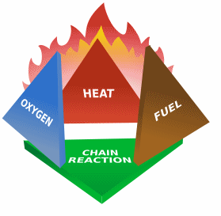
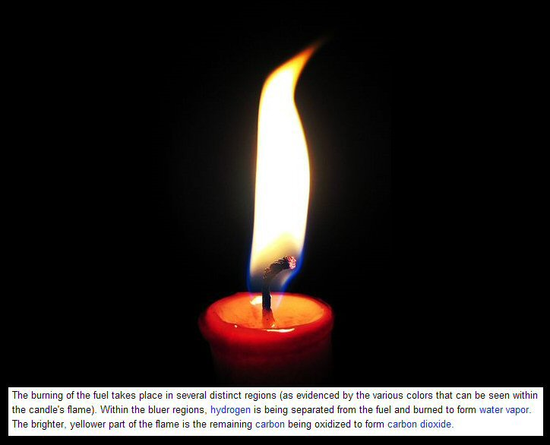
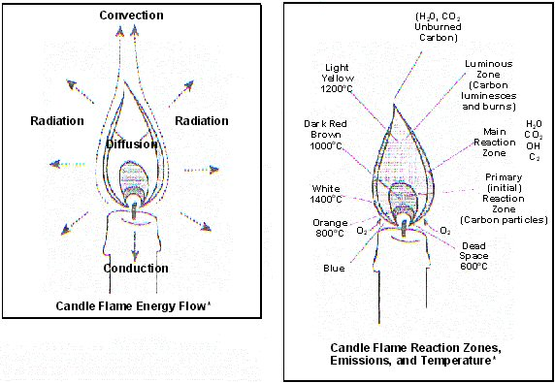
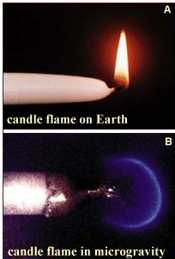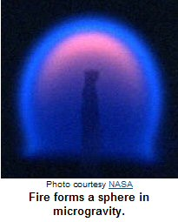

Elementary analysis
Wood has a complicated chemistry, but it can be broken down into an elementary analysis as follows:
Carbon | (C) | 41.0%
Hydrogen | (H₂) | 4.5%
Oxygen | (O₂) | 37.0%
Water | (H₂O) | 16.0% (Air dried)
Ash |  | 1.5%

Combustion reactions
During complete combustion, the following reactions take place:
C + O₂ = CO₂
2H₂ + O₂ = 2H₂O
During incomplete combustion, we get the following:
2C + O₂ = 2CO
All of these reactions are exothermic. They result in a conversion of chemical energy into heat:
1kg C + 2.67kg O₂ = 3.67kg CO₂ + 32,000 BTU or 9.6 kWh
1kg C + 1.33kg O₂ = 2.33kg CO + 9,500 BTU or 2.9 kWh
1kg CO + 0.57kg O₂ = 1.57kg CO₂ + 9,500 BTU or 2.9 kWh
1kg H₂ + 8.0kg O₂ = 9.0kg O₂ + 135,000 BTU or 40.5 kWh

Combustion air
The theoretical combustion air requirement is 3.6 cubic metres per kilo of (dry) wood. This is known as stochiometric air, or 100% excess air.

In reality, more than the theoretical amount of air is required, since some air passes through the firebox without taking part in the combustion. This is called excess air.

Excess air = CO₂max./CO₂measured
The maximum CO₂ possible in wood fuel flue gas is 20.9%

For good combustion, we need around 200% -- 300% excess air.

Efficiency
Combustion efficiency measures how much of the wood’s chemical energy is released during the burn. This is typically around 96 - 99% for most good masonry heaters. The chemical loss consists of unburned carbon monoxide and hydrocarbons that exit the chimney.
Heat transfer efficiency measures how good the appliance is at delivering the released energy to your house instead of out the chimney (stack). One way to define it is in terms of stack loss, something that can be measured with combustion testing equipment.
For wood, we will ignore the fact that the wood changes continuously in chemical composition as it goes from cordwood to charcoal, and assume an average composition. We’ve already dealt with the chemical loss due to incomplete combustion. There are three other types of stack loss.

Latent heat loss
This results from the fact that you are boiling off the water content of the wood into water vapor. It takes about 2,000 BTU to turn a kg of liquid water at 212ºF to a kg of gaseous water at 212ºF. Note that this loss does not involve a change of temperature, but rather a change of state from liquid to gas. It is termed latent heat, as opposed to sensible heat which is something you can sense as a temperature change. This is an unavoidable loss, unless you use a condensing chimney to reclaim the latent heat, as in a high efficiency gas furnace.
For wood that is at 20% moisture content, this ends up being about a 13% loss. One source of confusion with efficiency numbers and claims by manufacturers is that in Europe the latent heat loss is not counted. This means that if you see European literature on a stove claiming 80% efficiency, you have to subtract 13% to get a North American number.

Stack temperature
The gas leaving the chimney is above ambient temperature, which represents an efficiency loss. Obviously, you have to keep the gas temperature in the chimney above 200ºF to prevent condensation, which is undesirable unless your chimney is built specifically to handle it. You also need to maintain draft.

Excess air
If you are moving excess air through the system, it ends up at the stack temperature. Therefore, the more excess air, the higher the loss. With a masonry heater, we can pretty much pick whatever stack temperature we want in the design process. The main challenge is controlling excess air. Wood needs 200% to 300% excess air, or complete combustion will be hard to achieve and we will see elevated CO levels in the stack.
It is interesting to note that the theoretical maximum efficiency possible with a non condensing woodburning system burning wood at 20% moisture is about 83% overall efficiency.
Overall efficiency = Combustion efficiency × Heat transfer efficiency.
A very good real world number for a masonry heater is about 75% overall.

Wood Combustion

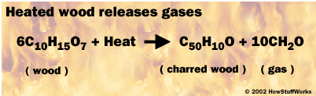

Emissions

Carbon Monoxide – CO
- Colorless, odorless gas
- Harmful to health in small concentrations, particularly long term
- Poisonous, can cause death in large concentrations
- Oxidizes to CO2 in the atmosphere, so is usually a localized problem
- CO problems are usually associated with urban areas and automobiles
- Measurable with a gas analyzer

Particulates – PM (particulate matter)
Soot
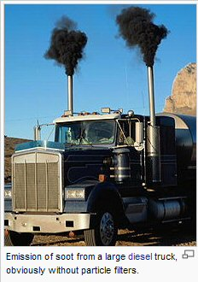
- Requires a flame to form
- Carbon (“lamp black”)
- Black smoke
- Very lightweight. You can have black smoke, yet a low PM number
- Test filters are black, but have no smell
- Measurable by sucking through a filter
- Doesn’t require a dilution tunnel, because there is nothing to condense
Tar
- Requires absence of flame (smoldering) to form
- Complex, semi-volatiles
- Condense at different temperatures
- Blue smoke. Smoke is blue from diffraction of light, due to the very small particle size
- 90% of particles are smaller than 1 micron (= 0.001 mm)
- The wavelength of blue light is 0.5 microns
PM2.5
- particulate matter smaller than 2.5 microns
- A blood corpuscle is 6 microns, so these particles are in the biologically active size range
- Measurable with a filter, but requires cooling first, by diluting with air (dilution tunnel)
- Heavy, gives a high PM number
- Test filters have a very distinctive “creosote” smell. If there is no soot, the filter can be yellow, like a cigarette filter

Volatile Organic Compounds – VOC’s
PAH’s
- Polycyclic aromatic hydrocarbons – carcinogenic
- Volatile, don’t condense into particulates
- Therefore not measurable with filters

Combustion testing:

Why Test?
- Research and Development: - build better heaters
- Field Certification: - verify that a one-off custom heater performs properly

What are we trying to measure?
- Efficiency, so that we burn less wood
- Emissions, so that we minimize air pollution and comply with regulations

Summary of the Heater Testing Cycle
- Measure the fuel going into the firebox
- Descriptive: Wood species, wood geometry, kindling sequence
- Quantitative: Weight, number of pieces, length, circumference, moisture content

- Measure what comes out the stack
- Stack temperature
- Stack gas composition: oxygen or carbon dioxide, carbon monoxide
  - Nitrogen does not change, so no need to measure it
  - Also don’t need to measure water vapor, oxides of nitrogen, sulfur
- Emissions
  - Particulates (smoke and soot)
  - CO (already covered by gas analysis)
- Calculate
- Can be automated with computerized spreadsheet templates
- Does not require specialized knowledge anymore, except to interpret the results
- Display Results
- We are looking at extremely complicated phenomena
- It would be nice to get easily comparable results, but that remains a dream
- Graphic results such as time lapse photography, and the shape of curves on graphs, help to make sense of it all and lead towards insight
- Analyze
- Once you have many results, you can start to mine them for insight
- Quality control of the data is job #1, otherwise you are mining garbage
- Communicate -- Keep Good Records
- MHA wants to develop a certification program for heater field testing
- By standardizing the procedure and the data reporting, it will allow us to build a long term performance database
- This will benefit the heater community and the environment
- It also allows us to be pro-active in the regulatory realm, with a credible supplement to existing approaches

Example Research Question:

Is there a relationship between CO numbers and PM numbers in masonry heaters?
- This is an example of an open technical question.
- In North America, PM emissions are regulated. In Europe, CO emissions are regulated.
- Europe is starting to regulate PM
- CO is easy to measure with a gas analyzer
- PM is tricky and expensive to measure, requiring a laboratory dilution tunnel setup.
- Fortunately, PM measurements in heaters can be simplified because we don’t make tar. This allows us to use the Condar portable dilution tunnel, do field testing, and get reliable numbers.
- MHA and Lopez Labs has pioneered this approach
- European heater testing until recently was for CO only, and the assumption was always that a clean burn (CO) will also give you a clean burn (PM)
- Based on the above graph, what do you think?
- Assumptions are one thing – measurements are another

TESTO 330-2 combustion analyzer

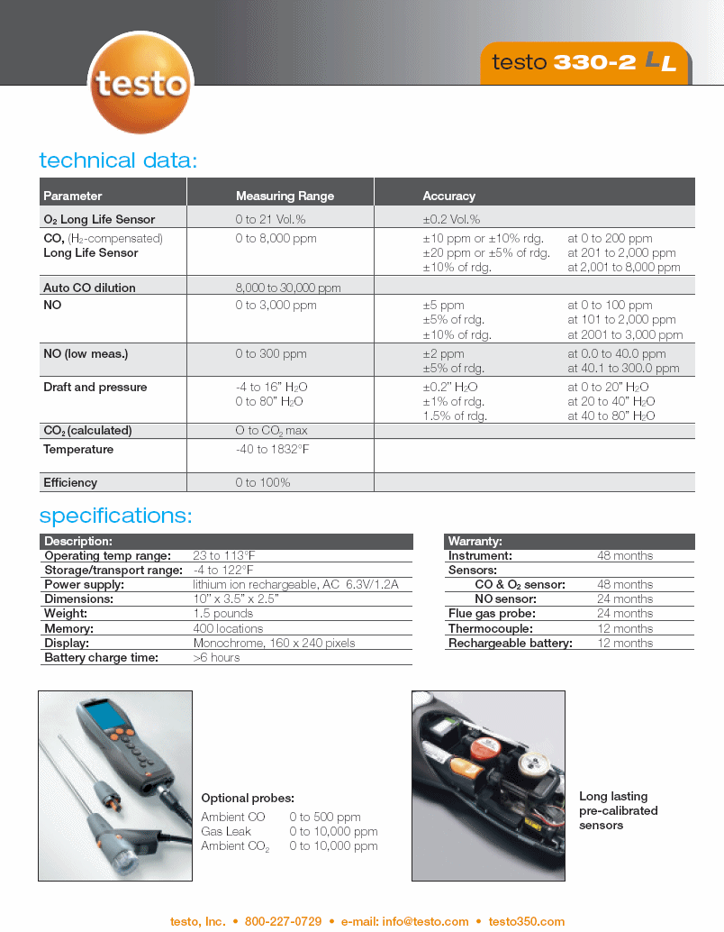

TESTO 350 emission analyzer

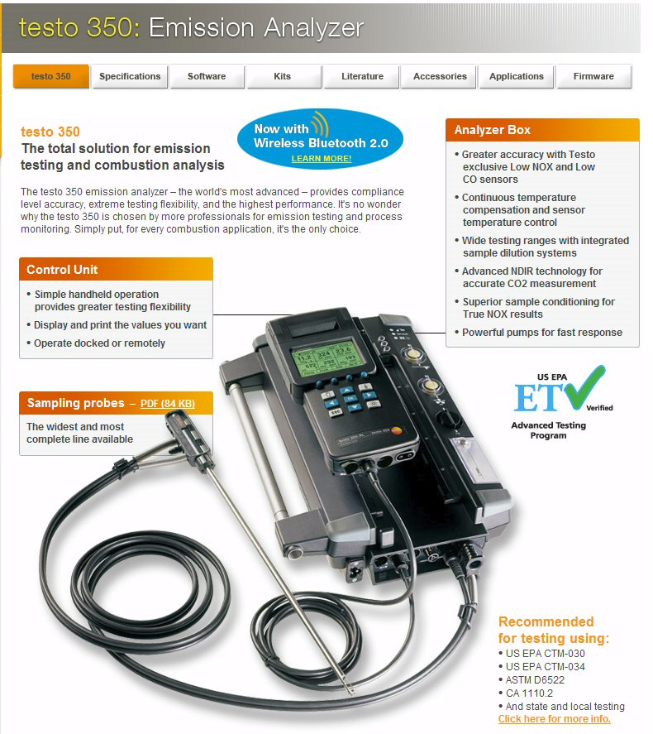

Condar Dilution Tunnel

Schematic of Condar Dilution Tunnel

Comparison Between Condar and Laboratory Dilution Tunnel Method

Test Instrument and Testing Concepts

Calibration
- Calibration gas
- Zero and Span
- Drift
- Repeatability
- Inter Laboratory Repeatability
- Instrument certification by EPA (Testo 350)

Data Quality
- Q&A Standards
- Traceability
- Chain of possession

Maintenance
- Sensors
- Calibration records
- Filters
- Water trap
- Cleaning

Automated Testing
- State of technology
- Software
- Instrument features: auto dilution, auto zero, auto rinse

Evaluation

