Workshop on

“The System of Free Gas Movement”

with Igor Kuznetsov

in Ekaterinburg, Russia, January 2004

Trip notes

by Alex Chernov
email: chernovalex@yahoo.ca

During my 10-day visit, I have stayed at Igor’s cottage in Murzinka, a little village 30km from the City. Igor usually spends nights at the cottage. At daytime, he works in his apartment in the City. We followed this pattern spending most of the time in the City and its area.
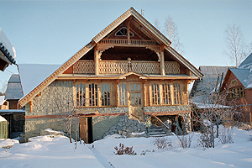
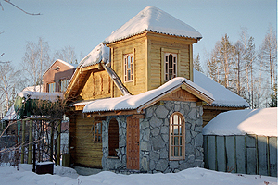
The Murzinka village has many newly built cottages, many of them have quite elaborate design, and many are decorated nicely. Most of the buildings are log structures; some of them faced with T&G planks in diverse patterns. Beautiful architectural details carved from wood can be seen here and there around windows, doors and along the roofline.
Almost every property has a Russian steam sauna called “Bania” built at the backyard. These log structures usually have four rooms: unheated verandah, and heated: steam room, bathing room, and room for relaxation. “Bania” is used for relaxation, for healing and for bathing due to the fact that most if not all of the houses don’t have centralized water supply system and, therefore, a bath inside the house. People don’t install water systems because such system will require constant heating of the house. It may be costly as normal winter temperatures drop below –30 Celsius, and unnecessary because people don’t live there all the time. Plus, septic systems, necessary for bath installation, are rare here due to their high cost.
Not many people live in the village all the time, although all houses are intended for all-season use and most use masonry stoves for heating. Most of the owners come here just for the weekend and for the summer. It is hard to say for sure, but the village has about 250 houses and 200 steam saunas. About half of the houses and saunas in this only village are heated by masonry stoves designed by Igor Kuznetsov and built by him and his team.
Igor’s cottage is heated by three stoves with four fireboxes (where one is a fireplace) located on three levels and working on a single chimney liner. The liner’s size increases as additional fireboxes (stoves) are connected to it. Its size at the last stove is about 260x260mm (10 ¼”x10 ¼”). The lower stove is a small simple heater located in the garage. The second one on the main floor is a Russian cooking-baking-heating combination stove with one firebox and a built-in fireplace. The fireplace is actually a part of the stove as the stove’s gases heat its walls and hearth. The stove has a 2-range cooktop and a bake oven, and heats gallery, living room and kitchen. The upper (third) stove is a heater that heats 3 rooms.
It was warm on the main floor when we arrived. I asked Igor when he fired the stove last time, and he told me that due to lack of time he currently doesn’t burn wood in it, and all the heat is generated by two 1kW electric heating elements installed into the stove. It is quite amazing because 2 kW it is not that much for about 500 to 600 sq. ft of floor space. The temperature in the rooms was about 20 degrees Celsius. The stove was warm on touch all around with its lower half warmer than upper, and air quality was very nice, not dry at all. Igor told me that such heating pattern remains when the stove is fired with wood but the heat intensity is higher. In electric heat mode, the shut-off damper has to be closed. It is very important that such use of electric heating elements doesn’t change radiant nature of heat released into the room. It makes an ideal back up for someone determined to heat his house with masonry heater only. It is obviously superior to use of baseboard electric heaters (normally recommended as a back up for a masonry stove) by efficiency and by healthiness.
I should mention that walls of Igor’s house and others are not insulated well. They are built from 6” or 8” round logs faced with T&G planks sometimes with maximum 1.5” of insulation (fiberglass or Roxul-type) in the gap from the outside. At the same time, Igor’s stoves provide sufficient heat even with loads of ¾ of the capacity that tells about their high heat output.

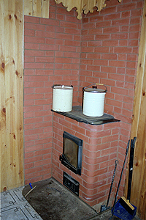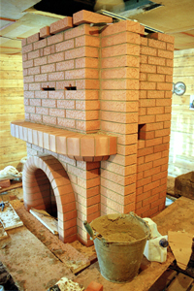

In the morning of January 29, we had a “masonry stove tour” of Murzinka village. We met several of Igor’s clients and looked at their stoves. There were sauna stoves, heaters, cooking-baking stoves and others. Many have a built-in fireplace. All the stoves look nice although their shape is usually simple, because people there built them for heating in the first place. Some of the stoves show really beautiful brickwork. Often, stoves were built from very low quality brick. Some of these bricks were cracked. I also noticed small cracks on the joints on a couple of stoves. It should be noted that all the bricks are laid on clay based mortar. All stoves are a single-wall construction, only fireboxes are lined with firebrick. I have talked to owners of the stoves with cracks and found that usually they had some improper firing practices. Some fired stoves or fireplaces very hot immediately after construction when 2 weeks drying period is a must for a clay mortar. In some cottages, construction workers “overfired“ stoves during building period, overheating the stove. We actually witnessed two instances when construction workers overheated stoves. Brick walls of one sauna stove we came to check were heated to 160 degrees Celsius even with half-open by-pass damper! No wonder that this stove shown some stress cracking. Stoves at Igor’s cottage, however, didn’t show any stress cracking although he uses them for more than 10 years. So, proper firing practices are important. Nevertheless, Igor believes that low quality of materials is his major problem. I agree with him. Materials used by his team of masons are indeed of low quality due to unavailability of high quality brick, mortars, and clays in the area. Now, Igor works on this problem, and situation slowly changes, but it is still far from the ideal.
It is interesting that people’s attitude towards stress cracking is generally very tolerant. It seems that cracks don’t bother them. I can just suggest why it is so. Partially, I believe, it is due to the fact that masonry laid on clay based mortar can be repaired easily and fast. Also, people there have lived with masonry stoves forever. Many old-type stoves had some cracks that had to be repaired time to time, so, they simply got used to it.

Location of all stoves without exception is very well thought out to reach an even temperature in the entire “heating contour”. “Heating contour” refers to an area intended to be heated by a single stove. Such area, as Igor believes, should be not larger than 650-700 sq. ft. Stoves’ walls are exposed into different rooms providing just enough heat for each room. Stoves are usually located at wall intersections with walls or other parts of the stove exposed into adjacent rooms. Fire protection is achieved by brick-wide “wall starters” laid between the stove’s surface and walls. Proper layout for a heating contour is designed by Igor and is always included in client’s proposal, which in reality becomes an all-embracing solution for particular client’s heating needs. This is a unique service unavailable from others in the trade in Igor’s region, and perhaps in other areas too.
This way, for instance, one stove heats entrance hall, kitchen and living room. Firebox, in this case, can be located either in the hallway or in the kitchen. Part of the stove, exposed into the kitchen may have a cooktop and a bake oven. A wall exposed into the living room may have a fireplace. We have seen several of such stoves. I talked to their owners and found that they all are very satisfied by their stoves. Some of the owners had masonry stoves of other design before, but dismantled them and had Igor’s stoves built for them instead. They all say that Igor’s stoves are superior to others. They say stoves use a lot less firewood, get heated evenly, and have high heating capacity. They all fire stoves ones a day, and for a relatively short period of time.

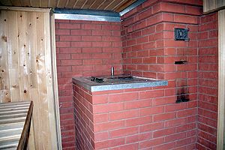

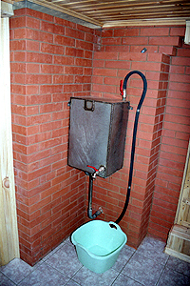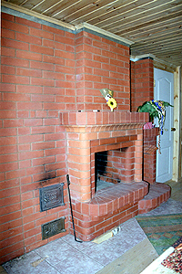

Stoves for Russian steam saunas deserve special attention. Requirements for such stoves are numerous and complicated. Such stove has to heat three rooms, maintaining different temperature in each room. It has to produce high temperature (superheated) steam and maintain a desired balance of temperature and humidity in the steam room, and also, it has to produce hot water. All this has to be done without use of electric power. All these requirements are achieved in Igor’s steam sauna stoves that are a true masterpiece of the stove designer.

We have visited number of “Bania” saunas that have Igor’s stoves. Such stoves may have firebox in the hallway or in the relaxation room. Relaxation room is a room where you would rest between visits a steam room, drink tea or beer, chat with friends. One wall of the stove is exposed into the room and heats it. Often it has a fireplace that as was mentioned before, is a part of the stove and is heated all around by the stove’s gases. From the relaxation room you get into the bathing room heated by another of the stove’s walls. In the bathing room, there is a hot water tank connected to a hot water coil installed into the stove. Floor here is sloping with a drain installed at the lowest point. Another tank with cold water is installed at the floor. For bathing, you would mix hot and cold water in a bucket.
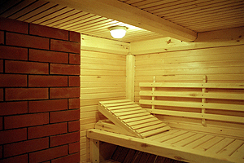
From this room, there is a small door leading into the steam room. About two thirds of the stove are exposed into the room. This part of the stove has a built-in container filled with stones. Steam is produced by pouring water onto the stones inside the container through special openings. Hot gases heat the container, so the stones don’t have direct contact with the flame. It results in ability to continue firing while using the sauna. Igor uses different shapes of stone container and various methods of pouring water to produce steam of the highest temperature possible. His latest models are very successful in and also have an option to work in a dry sauna heater mode.

Temperatures in the rooms are maintained as follows: 22 – 25 degrees Celsius in the relaxation room, and 30 –35 in the bathing room. Temperature and humidity in the steam room depends on particular stove’s design. Igor designs each sauna stove to suite client’s desire. Most of the clients consider 60 degrees Celsius and 40% humidity comfortable for a steam room, and their stoves create these conditions. A number of sauna stoves with ability to control and change temperature and humidity in a steam room were successfully designed and built by Igor as well. A coil made from a stainless steel is installed into the stove with small dampers attached to its ends. By opening the dampers, one lets air circulate through the coil that quickly rises temperature in the room and dries out the air.
I had bathing experience in two of such “bania” steam saunas. On the evening, January 29, I was invited to Igor’s friend’s “bania”. His friend’s name is Rim. Rim was so excited by the opportunity to show his “bania” to a mason from Canada, that he overheated it. I have to say that steam sauna stoves require quite long firing due to a large mass of stones that have to be thoroughly heated through. Usually, about 3 to 4 hours are sufficient. Rim fired his stove for 6 hours. We came with Raytek thermometer and measured temperature of the stove’s walls 2.5 hours after the shut-off damper was closed. Walls are half-brick thick that is equal to 120mm in Russia. Here is the data we collected in degrees Celsius:

surface, 8" above the firebox | 160
surface, lower half | 100
surface, upper half | 80
stones in the container | 435
surface around stone container | 160
surface , other areas | 70-90
Cast iron firebox door | 254

The relaxation room didn’t have a thermometer, but I would estimate that it was around 26-28 degrees. Temperature in the bathing room was 45 degrees, and the steam room had 90 degrees with 20% humidity. Atmosphere in the steam room resembled a dry sauna more than a steam sauna. I have to note, that Russian steam sauna’s concept requires relatively low temperature with relatively high humidity content. This way one can achieve maximum healing and cleaning effect without any discomfort and harm to the body. As was said before, 60degrees with 40% humidity is a good combination for a “bania”. Usually, sauna stove has to heat the steam room to about 40 degrees, and then temperature is lifted up by throwing water onto hot stones. This way one can achieve a comfortable combination.
Obviously, Rim’s steam room was overheated. Throwing water on the stones lifted humidity only to 23%, but made atmosphere hardly bearable. So, we spent most of the time in the relaxation room drinking tea and discussing construction methods and techniques in Canada and Russia.

We came to Rim’s “bania” next morning and measured surface temperatures again, now 18 hours after firing. Here is the data:
surface, 8" above the firebox | 60
surface, lower half | 55-60
surface, upper half | 52-54
stones in the container | 150
surface around stone container | 70
surface , other areas | 52-60
Cast iron firebox door | -

You can see that temperatures more or less leveled out all over the stove’s body. I should mention that it was a remarkable characteristic inherent to all of the Igor’s stoves I have seen. They become evenly heated all over the surface several hours after firing. Also, this particular stove kept heat very well. A large stone massive (about 400 lb) helped to keep the heat, but we have to remember that it was well offset by walls and ceiling that were not insulated well. Temperature in the bathing room dropped to 37degrees, and in the steam room it was 75 degrees with 18% humidity.

My next “bania” experience was much more pleasant. It was Igor’s own “bania”. His wife fired it properly and we had a very nice evening. His steam room didn’t have a thermometer and hygrometer, but it felt to me as it was very close to the ideal conditions. If atmosphere in the steam room is well balanced, even intense heat is bearable and you can breathe with ease.

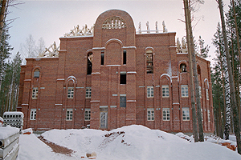
One day we have visited construction site of a future monastery. The largest structure of the monastery is a 3-story brick building where two lower stories are designed to have residential units for monks, and the upper story will serve as a large temple. Igor has designed and built a wood-burning boiler for a hydronic heating system of the building. Although the building is still under construction and the temple at the third floor doesn’t have a roof yet, wall units were installed on the first and the second story and the system is already working. Results achieved with the boiler are very impressive.
First, I have to tell more about the 11000 sq. ft building itself. This brick structure’s height is 14m (23m to the top of the main tower bearing a cross). Walls are about 2 ft thick insulated at the middle with a high-density mineral wool 5” thick. Walls are not plastered yet inside and outside. Some windows are already installed; others are just covered with plastic film. Slab between the second and the third floor is made from separate cored concrete units and is not insulated yet. The third floor doesn’t have a roof yet. Even with all this conditions and outside temperature of minus 16 degrees Celsius, temperature inside was +12 at the first story and +15 at the second story! Walls and ceiling slabs had +10 degrees!
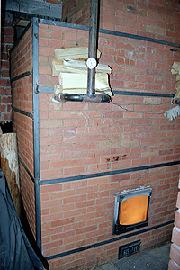
The boiler is a quire large brick “single-chamber” or “single-bell” stove of 6.8 cubic meters of volume with four hot water coils made from 2 ¼ “ steel pipes. Total surface of the coils is equal to 137.5 sq. ft. The coils are installed outside of the firebox in the chamber. The boiler is installed in a special room on the lower level, and the hydronic system works by gravity, although two emergency pumps are installed at the return pipes. The stove has metal braces at the corners and between them, and eventually has to be heavily insulated with mineral wool. At present, it wasn’t insulated at all. Currently, the boiler is fired constantly although Igor has designed it with a big reserve so, that after construction and all insulation works are finished two or three firings a day are sufficient. Number of units was calculated for the capacity of 60kWt/h while Igor’s calculations using old methods shown 125kWt/h as the minimum boiler’s capacity.
We measured temperature of the stove and pipes’ surface with Raytech thermometer. Stove’s surface above the firebox was 130 degrees Celsius; other areas were 80 to 90 degrees. Water in the supply pipes just out of the boiler was 54 degrees when the system worked by gravity. Unfortunately, we didn’t measured return’s temperature in this mode. With the pumps running, supply temperature was 49 degrees, and 42 on the return! All this means that stove’s capacity was greatly underestimated. It was designed to heat only two lower stories, but everyone believes that it can easily heat the whole building. Indeed, with insulation, it is very likely possible.

We also wanted to measure temperature inside the firebox, but we got 535 degrees (that is maximum for this particular Raytech model) just 6” from the door. Further, it was too hot to measure. Igor has used a new idea in the stove’s design. Outlets from the firebox have a special shape that contributes to complete combustion and thus, Igor calls it a “catalyst”. Relatively thin elements of this part got heated white-hot and ignite all unburned gases at the exit from the firebox. People serving this boiler are amazed by its characteristics. They burn freshly cut pine because they don’t have dry firewood around, and nevertheless, they get only one bucket of soot left after 15 days of constant burn! They experimented by throwing a piece of rubber into the firebox, but they didn’t get any dark smoke. All they get is white vapors!
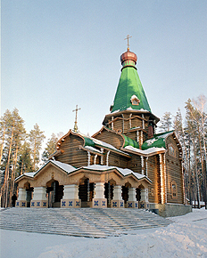
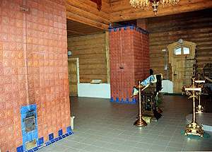
All this is very impressive. Igor continues to work on the improvement of such boilers. The described one is a single-wall construction with a firebrick liner in the firebox, but the next ones Igor is going to build with an independent firebrick core insulated from the facing. I should say that use of our, North American, materials and technology in construction of such boilers can lead to the birth of a family of very efficient and durable wood-burning boilers superior to others.

During my stay, we also visited a big monastery Ganina Yama built at the place where Tsar’s family was massacred by Bolsheviks.

The monastery has many churches, temples and other buildings. Igor’s stoves heat all the buildings, except for two of them. The most impressive are two stoves that heat the main hall in the biggest temple. Volume of each of the stoves is 370 cubic feet! The monastery had stoves built by other masons before, but those stove were inefficient and caused many problems. They have switched to Igor’s stoves about two years ago, and are very happy since.

On one day, we had a meeting with a head of a scientific department of a local University. His team became interested in incorporating Igor’s ideas in scientific research for development of new efficient power generators and boilers working on by-products of the forestry industry. After the meeting, an agreement was reached for conducting of laboratory testing and research of Igor’s boilers. It is planned that preparation for the testing will start the next week.

Scale of stove construction in Igor’s team is enormous. His Ekaterinburg team has about 20 masons working in the City and area, and about 20 masons working all over the Russia and bordering countries. Only in Ekaterinburg, his team builds more than 200 – 300 stoves a year. Igor built stoves himself since 1962 and formed his team of masons in 1989. It can be said for sure, that since then, more than 2500 stoves were built by Igor himself and by his team. During my 10-days stay, I have witnessed beginning of 6 new projects, and visited numerous projects under construction. Most of the masons in Igor’s team were employed although winter is always a slow time for them. They say that summer is a crazy time, and they often have to create waiting lists for clients.

My short visit is over. First impressions are written down, and I am leaving Igor’s welcoming family and his City. I am filled with information and new ideas, and inspired by Igor’s work and by unlimited possibilities of his “system”. I am sure that amalgamation of his ides and North American technology and materials will result in superior masonry stoves that will serve people for good for many years. I believe that this “system” with its incredible flexibility will help people to own masonry stoves that are always individually designed and tailored for each and every client. I hope that wide use of renewable energy sources will soon become reality in Canada and the US, and this work will help this movement.

Alex Chernov
Ekaterinburg, Russia – Ontario, Canada.

