Gas Plant Boilers (heat-generating boilers)
in the System of Free Gas Movement

By: Igor Kuznetsov
http://stove.ru

The present article deals with questions concerning gas plant boiler design. It is known that the calorific value of producer gas is lower than that of gases of destructive distillation. Due to that cause pyrolysis of fuel is carried out in devices with external heating. The basic method for boiler build-up is the method described by the formula
« The plant consists of a number of bell-type furnaces, each of them being surrounded by heat - accumulating bell, which in its bottom level contains free gates to connect them with each other. The upper part incorporates channels for interconnection of bell-type furnaces and heat-accumulating bell. The channels are provided with gates». It shall be pointed out that the above formula as priority application for invention of method for creation of energy installations, is property of world community. This method is described in detail in the article « Charcoal burning unit in free gas movement system» http://www.stove.ru/index.php?lng=1&rs=124 (1), as well as in the appendix. Some of the material and notions is used in this article. Wood-cutting area waste, nonmarket timber, waste of woodworking industry, cardboard boxes, wood cases, debris from the shops or markets may be used as fuel for gas plant boilers. Fuel mixed with snow can also be used. Raw material having the size of 35-45 mm has the highest pyrolysis speed. With this size of raw material the energy consumption for pyrolysis is the lowest. It is advisable (but not obligatory) to have raw material of this size, i.e. it shall be processed in crusher.

What are the requirements applied to power plant, and what are the functional tasks that shall be solved?
- Fuel preparation for pyrolysis;
- Combustion power adjustment without reducing the efficiency;
- Providing with best conditions for combustion;
- Optimal use of energy, including heat of exhaust gases;
- Ensuring of continuity of operation of boiler during fuel charge;
- Automation of fuel supply;
- High repairability;
- Ecological requirements.

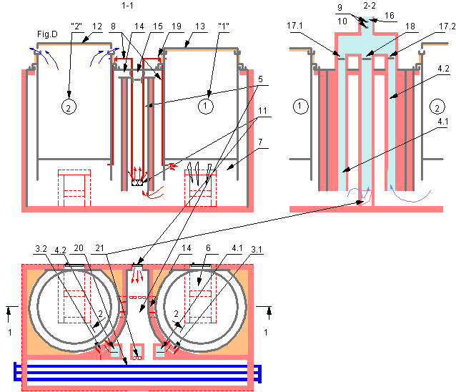
In order to solve the tasks set forth a diagram is proposed, showed in Fig. D comprising two or more retorts (furnaces).
The following designations are used in the diagram: “1”-“2”, - bell-type furnaces (furnaces) with retorts; 3.1-3.2, - inlets of pipes of direct flow of furnaces 1 and 2; 4.1-4.2, - direct flow pipes of furnaces 1 and 2; 5, - heat-accumulating bell; 6, - fire box for wood; 7, - retort combustion chamber; 8, - pipes to supply vapour gases to fire box 11, heat-accumulating bell , and combustion chamber of retort 9 and 10, - temperature elements and contents of effluent gases; 11, - fire box of heat-accumulating bell (built in accordance with the formula " the stove’s lower level and the fire box are combined to form a single space creating a lower bell” ; 12 и 13, -retort covers in open and closed state respectfully; 14, - interconnecting channel between retorts and heat-accumulating bell with a gate 15, - three-way gate; 16, - pipe; 17.1 and 17.2, - adjustable gates in direct flow pipes; 18, - pipe gate; 19, - a three-way gate, directing the necessary volume of vapour gas in the required direction ; 20, - water boiler, gas-air radiator of recuperative type (air being heated is separated from the combustion products ) for heating or for technological purposes; 21, - pipe inlet .
Appendix.
« Heat-accumulating bell», if it is provided with direct exit of smoke gases to the pipe, or through the next bell located in gas flow direction, through «Medium» provided with depressurizing zone (-Р). It can accommodate a boiler, gas-air radiator used for heating or technological purposes, that is consumer or heat source, or both components can be used together.
«Bell-type furnace», (hereinafter referred to as the «furnace»), if the furnace is not provided with an outlet for hot gases directly into the pipe, and the gases are exhausted through heat-accumulating bell, that is through «medium», having a depression (-Р).
The features of the system at different time of operation are described in the above-mentioned article and appendix.
Fig.D, features cross-section 1-1 over the axles of retorts of furnaces No.1 and No.2. The furnace of each retort is an independent furnace with an ash-pit, fire box door, fire-grate, fire box, having the form of a bell with a retort installed inside the furnace. Each furnace is separated from another one by means of heat-accumulating bell. It is foreseen that one of the furnaces is operating while the other is used for fuel preparation for pyrolysis process. At initial heating of retort using wood as fuel, vapour gases are formed inside the retort, which are burnt inside the furnace and heat-accumulating bell. Another type of fuel, for example, electricity may also be used for initial heating of retort. It can be done when automation of heat generator operation is required. In the lower part of retort a combustion chamber is installed incorporating fire box for wood and nozzles of gas burner, through which vapour gas produced during pyrolysis process is burnt. Air necessary for combustion reaction is also supplied (using regenerative technology). The heat obtained is used for pyrolysis and for heating of boiler or radiator. During pyrolysis pressure is created in the retort. Retort heating adjustment (heat generator power) is carried out due to redistribution of volume of incoming of vapour gas for burning in different directions. Vapour gases may be burnt in the furnace or in heat-accumulating bell. The necessary direction of vapour gases in the necessary amount is ensured with the help of three-way gate. Vapour gas combustion takes place in one of the burners of the fire box at each period of boiler operation. Self-ignition of vapour gas may take place at any moment of process cycle, as soon as it comes out from another retort.
Exhaust of gases from the furnace takes place in the lower zone. Hot gases are supplied to heat-accumulating bell in accordance with the diagram shown in Fig.B2 in appendix.
Let’s view the plant operation in different modes and during various time of operation. For example, furnace No.1 is operating while furnace No. 2 is used for fuel charging (including mechanized charging) and fuel drying, cover 12 is open.
The plant can be started by means of any furnace, heating it with the help of wood combustion. In this example the furnace is started through the furnace No.1. As a result of retort heating vapour gases are formed inside it and the pressure increases. Vapour gases are supplied through pipes 8 for combustion to combustion chamber of retort 7 or to fire box of heat-accumulating bell 11, depending on the position of three-way gate 19. Gate 19 may redistribute the supply of vapour gas in the required amount in the necessary direction. In operation mode power adjustment of boiler takes place due to redistribution of volume and location of combustion of vapour gas without decreasing of efficiency. Maximum combustion capacity is reached during supply of total amount of vapour gas into combustion chamber 7. When the total amount of vapour gas is delivered into the fire box of heat accumulating bell 11, the boiler (heat generator) can be slowly switched off. During normal operation vapour gases are delivered and subjected to combustion simultaneously both in the furnace and in heat-accumulating bell. The initial heating of furnace is carried out with the gate direct flow 17.1. in open position.
The hot gases from furnace No. 1 flow as follows.
When the boiler is operated at the preset value the connecting channel 14 is closed by means of gate. Hot gases flow to heat-accumulating bell 5 through opening 22 and give off heat to water boiler (radiator). After cooling they are delivered to pipe 16 through opening 21. Gate 18 is open, gates of direct flow, 17.1 and 17.2 are closed. Transducer 10, depending on the content of effluent gases exert their influence on execution mechanism of radiator of regeneration system and optimizes air supply, necessary for combustion. Transducer 9, at high temperature of effluent gases actuates the executive mechanism of gate 18, closes it and opens gate 17.2 of direct flow channel of furnace No.2. In this case exhaust, so to say cold gases, flow through furnace No.2 and are discharged through the channel of direct flow 4.2 into the pipe. Flowing through furnace No.2 gases give off heat thus heating the retort. In other words, they are used for fuel drying. In case the temperature goes down below the permissible value and gate 18 slightly opens. It is but natural that this process can be adjusted manually.
In this mode it is possible that the boiler (heat generator) may dry out fuel even more efficiently. For these purposes horizontal and vertical left shutter of gate 15 are open. Hot gases flow from the upper section of heat –accumulating bell into furnace No.2. Heat-accumulating bell joins the bell of furnace No.2 to form a single bell. Further the gases may be delivered to pipe either through opening 21 or opening 22 depending on position of gates 17.2 and 18. It is natural that the gates may occupy an intermediate position, which means that they may be slightly open. We may speak about optimum use of heat produced due to the change of flow ways of exhaust gases.
Start-up of furnace No.2 into operation is possible without its heating by means of wood combustion. At finishing stage of operation of furnace No.1 the cover of furnace No. 2 closes, and hot gases are delivered into it from furnace No.1and heat-accumulating bell. With this purpose the gates of locking device are open. At this moment gates 17.1 and 18 are closed and gate of direct flow 17.2 of furnace No.2 is open. Hot gases flow through furnace No. 2, channel of direct flow 4.2 into the pipe, heating retort. Vapour gases are delivered into the fire box of heat-accumulating bell where they inflame and increase temperature in it and also in heat-accumulating bell of furnace No.2. When the temperature inside the furnace reaches the value of 180-200 ° C the vapor gases are delivered to combustion chamber of retort.
Heat accumulated in heat-accumulating bell is used for heating of boiler (heat generator) or my be delivered to any of the furnaces for drying fuel or for other purposes. The adjustment of drying process of fuel is carried out by means of opening or closing of gates of locking device. The combustion catalyst can be accommodated in combustion chamber of retort as far as the height is concerned. It is necessary both for wood combustion stabilizing during start up and for vapour gases in operating mode. The whole process may run automatically.
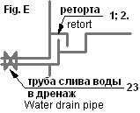
When wet fuel mixed with snow is put into the retort and during its heating much moisture is accumulated inside it. Water contains much debris that floats on the water surface and also much heavy debris in the water. In order to discharge water a mechanical cleaning device is foreseen in the bottom level of retort, from which water over the pipe through the valve is discharged into the drain system. Fig.Е features the diagram of this cleaning unit. Water drain pipe is protected from ingress of resin into it. Organic debris burns out, and mineral debris serves as drainage and is removed from time to time.
When retort is removed from the furnace, for example, for repair, it is not necessary to close opening in the furnace at once, as insufficient draft directed downward arises in it. Atmospheric air comes into heat-accumulating bell at the bottom level and flows into the pipe, cooling it a little bit (gas damper effect). Hot exhausted gases from the heat-accumulating bell flow into the medium with depression, that is into the pipe. The system operates in accordance with the diagram shown in Fig.В3. (1)
Heat generator may be used as an effective heat generator in technological plants processing timber waste into granulated fuel, in various types of dryers, etc. Using heat generator of our system it is possible to get controlled heat flows of hot gases of recuperative type or with combustion products, at constant value of vacuum created by the vacuum fan of process plant. In this case the design of heat generator walls is different.
Appendix.
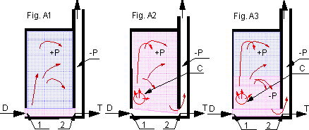
In order to better understand principle of operation of heat generator let’s view some of the basic moments.
The bell is called “heat-accumulating bell», if it is provided with exhaust gas outlet directly into the pipe or into the next bell located in the direction of gas flow, through “medium”, having depressurizing zone (-Р). The heat-accumulating bell incorporates fire box, - block made up of several pipes with burners. Such bell is shown in Fig..A1.2.3). The form of the bell as well as its volume may be different. For example, it may be round, rectangular, cruciform, etc. It may have any heat consumer inside (water or air boiler. etc) or heat source or both consumer and heat source together.
The diagram has the following designations: Letters D and T meaning blast (blowing) and draft correspondingly blast into the bell and draft from the bell. Blast creates in the bell “Medium” with excess pressure having a designation «+Р», and draft «Medium» with depression ( vacuum) «-Р». Blast and draft are applied at inlet and outlet points into and from the bell1 and 2. Hot gases carry heat energy and products of combustion. We are interested in heat energy transfer. Therefore, we may accept that an electric heater is a source of heat. It is marked with a letter “C”. In this case it is not necessary to remove the products of combustion.
If we supply a certain amount of air into the bell in a unit of time through point 1 and remove the same amount of air from point 2 in a unit of time (when the temperature inside and outside the bell is equal), in this case pressure in the bell won’t change. That is, if blast D and draft T are equal, then pressure in the bell remains without change. If hot gases are supplied into the bell from a certain environment temperature and pressure inside the bell will increase. Hot gases give up their heat to the bell walls and to the consumer located inside it. Fig. A1 features this case. As the temperature increases gravitational head (pressure) arises in the bell. At this moment temperature and pressure in each upper section increases. This increased pressure appears over the whole height of the bell.
If we install an electric heater into the bell, even in case of insignificant excess of draft over blast temperature and pressure will increase in each upper section. Hot gases after they have given up their heat to the bell walls and to heat consumer located in it, flow to discharge zone created by the draft. Excess pressure is created over the whole height of the bell. Such a case is shown in Fig. A2.
Let’s view the condition of the system if we install an electric heater into the bell when the draft is significantly larger as compared with the blast, Fig. A3. Two forces specifying the condition of the system act on gas flow. These are pipe draft (natural or artificial) and gravitational (temperature) head. Pipe draft impact (depression) is getting low in each upper section, while temperature head increases. In the lower level of the bell the total pressure creates depression, which is specified by the preset values of pipe draft and temperature. On a certain height these two forces become equal and there will be no depression. Above this level high pressure is formed in the bell. The temperature will increase in each section, which is located higher. Hot gases heat the bell’s walls and heat consumer located inside and then flow to depression zone created by the draft.
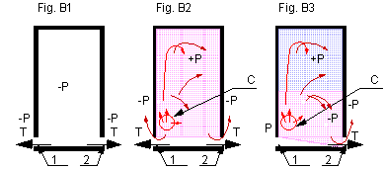
Let’s view the bell shown in Fig. B 1.2.3. Let’s call it ”bell-type furnace”, hereinafter referred to as the furnace. If the furnace is not provided with exhaust of hot gases directly into the pipe then the gases are exhaust through the heat-accumulating bell shown in Fig.A3, that is through “environment” having depression (-P). The form of the furnace as well as its volume may be different. For example, it can be round, rectangular, etc. It may have any heat consumer inside (retort for pyrolysis of wood at drying stage, etc) or source of heat (retort at the working stage or at cooling stage, etc).
If the furnace has no heat consumer or is provided with it then vacuum is created inside it. Such condition of bell-type furnace is shown in Fig. B1.
If the furnace is provided with a generator (a source) of heat high pressure is formed inside it and the so-called cool, exhaust gases flow from it into heat-accumulating bell, that is in “environment” having a depressurized zone. Temperature and pressure in the furnace will increase in each upper section. Such state of the system is shown in the drawing, Fig.B2. If in this case from the side of point 1 there is “environment” with atmospheric pressure (P) then hot gases will flow towards point 2, into the “environment” containing vacuum. Such state of the system is shown in Fig. B3.

References:
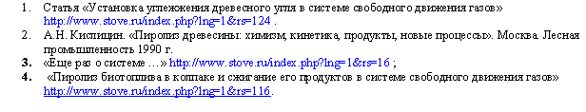

I.Kuznetsov, 25.03.2005

620042 Ekaterinburg, Russia
Pobedy str., 51-87
voice: (343) 332-94-90, 337-24-96
e-mail: igor@stove.ru
http://stove.ru

