Boilers and their piping

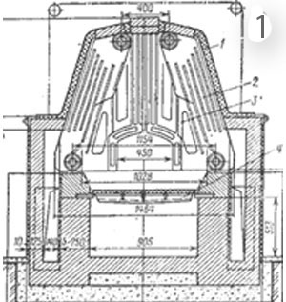
In Russia there is a tendency to decrease the volume of bulky centralized heat supply of different objects and increase the amount of off-line heat sources of different capacity that operate on inexpensive local fuel. Many countries implement programs aimed at increasing the use of biological energy. There is a demand in boilers of continuous action to be used in the systems of utility energetics as well as for heating living houses and industrial buildings both in Russia and in developed countries of the West. All the boilers being used ate built in 1 the system with forced gas movement. However the boilers of forced gas movement system (shown in Fig.1 are not allowed by Environmental Protection Agency (EPA) due to low efficiency of fuel combustion, i.e. fuel combustion purity. The attempts to create effective wood boilers in the system of forced gas movement brought to a number of accidents, therefore such boilers cannot be covered by insurance. Within many years the design of power installations of forced gas movement regarding heat engineering have been brought to the highest possible level and practically there’s no chance for their improvement any more. In the boilers of forced gas movement system there’s no place for heat exchanger installation. The heat exchanger in the firebox reduces the temperature in it, worsens combustion conditions. In upward channel of large section the gas flow is distributed nonuniformly. In downward channel the gas flow is distributed along the section uniformly, its temperature decreases, the gas flow is in constant motion, and the heat exchange worsens. However more and more people would like to have wooden boilers.
The stoves and boilers of this type possess significant drawbacks that are difficult to compensate due to imperfection of the system used. They are based on the principle of forced movement of hot gases. Their convective system consists of a number of consequential, parallel or combined-located channels. The system is characterized by a large resistance to gas flow, it is limed by the form and volume and it preserves and transfers the heat nonuniformly and inefficiently. Also it is not possible to insert a heating boiler into the channels. For these purposes only the space of the firebox can be used. In such case the functional purpose of the firebox changes, here appears a cold core that decreases the temperature in the firebox, significantly decreases the efficiency of heat extraction of fuel and combustion purity.
Heat generators of Forced Gas Movement System. THIS IS A PREVIOUS LEVEL OF TECHNIQUE.
The main feature of heat generators of forced gas movement system is that in the firebox there is no gas separation as per heating degree. Gases, heat carriers come to the convective system as a mixture with ballast gases. One part of the gases is heat sources, the other part - heat consumers. They get mixed in the flow, their temperature gets lower and the conditions of fuel combustion get worse.
Boiler of our system of free gas movement give everybody hope and possibility of having efficient and ecologically friendly boilers.
New, ecologically friendly systems of heating installations using renewable fuel sources need to be used. These systems shall be flexible and could be easily modified for their use as heat energy source for an individual object and also as heat supply source to be used for several objects.
Our system of free gas movement for construction of heating devices fully corresponds to the above-mentioned conditions and provides a number of additional possibilities and conveniences for people.
For heating of individual houses boilers of periodic action are required that can accumulate heat during one-time or two-time firing during 1-2,5 hours and ensure the required heat mode within 24 hours. If it is required to maintain a certain heat mode in the house, at each period of time within 24 hours one can use electricity or heat-accumulating tank.
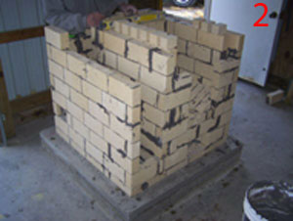
2 Because of prohibition of boilers of forced gas movement system МНА on August 12-14, 2008 had arranged a workhouse in Ontario. A 17 kW boiler of our system was built there and it is used till now (refer to Fig.2), http://heatkit.com/html/lopezs.htm
The same type of boiler was built in February 2009 and is being used now in Western Ohio, USA. The water heating system was made using heat-accumulating tank. The boiler heats the house of 420+117 m². The boilers have high efficiency factor and pure combustion. Many people from different countries address to me with a request to provide information or build a boiler of our system at their place.
A piece of theory. Let’s fill the bell К1 shown in Fig.A1, diagram 3 with a portion of hot air.
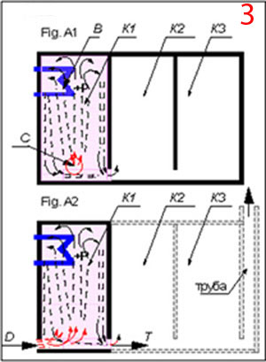
3 Legend on diagram 3 is as follows: К1, К2, К3 are numbers of bells 1, 2, 3 as per direction of movement of hot gases; В- heat exchanger; С- electric heater; D- blast; T- draft;
Hot air being lighter goes upward and removes cold heavy air from the bell. It will be present there until it gives out its heat to the bell’s walls.
If hot air generated by electric heater C is constantly supplied to the bell, part of the flow heat is taken by the bell’s walls and the heat exchanger B placed there. If more heat is generated than the bell with the heat exchanger can take in, than the surplus of heat (cooled air from the lower zone of the bell) will come to the second bell К2 and from there to the third bell, К3, if К2 cannot accept the whole heat. Hot air moves in the bells without chimney draft due to natural forces and does not require any external energy.
In the system of forced gas movement heat transfer is possible only due to chimney draft.
If we pass the flow of hot gases received from fuel combustion in the bell located outside the bell, through the lower zone of bell К1, shown in Fig.A2, diagram3, then when blast D and draft T are equal, hot particles under the action of Archimede’s force rises upward, to the zone where heat exchange processes take place.
The heat of hot gases will be transferred to the bell’s walls and to the heat exchanger places inside the bell, and the surplus of heat (cooled air) will come out to bells колпаки К2, К3 etc., if they are available.
As heat exchanger water boiler register, air-heating radiator, retort for fuel gasification, technological materials, etc. can be used.
Theoretically it is possible to select such heat exchanger that will take in all the heat. In this case one can say that the efficiency of the extracted heat is close to 100 %.
Heat transfer from the gas to the heat exchanger depends on the following factors: heat exchange square; temperature difference; contact duration.
The larger and the longer they are, the more is the heat exchange. The bell can be of any form and volume, in which the heat exchanger can be placed, i.e. to increase the heat exchange. If the heat generator is made in such a way, the square of the heat exchange and the duration of contact of hot gases with the heat exchanger will increase, therefore the heat exchange is improved.
Combustion products are carbon dioxide, received in the result of carbon combustion (СО2); water vapours from combustion of hydrogen and also ballast gases, water vapours of fuel, air surplus with increased nitrogen content. This gas flow passing through the lower part of the bell is distributed by the content. Each particle of the gas flow has its own state (mass, temperature, energy) and occupies in the bell during free movement through it place determined by this state. Hot constituent of the flow under the action of Archimede’s force rises upward, exerts an influence on the heat exchanger and is present there until the gases cool down. Cold, heavy and harmful constituents of the flow, most cold streams pass over the lower part of the bell and exert a small influence on the heat exchange.
In the boilers of traditional design in the system of forced gas flow such an impulsive force can be chimney draft or mechanical blast-draft.
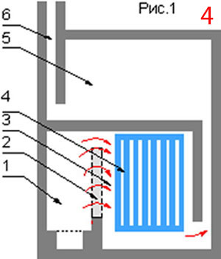
4 From the above-mentioned an important conclusion can be made – when the gas flow passes through the bell the efficiency ratio of use of the extracted heat increases as the influence of the ballast gases on the heat exchange decreases.
On the basis of this phenomenon the convective system of all our boilers is built.
The boiler consists of the firebox and convective system in the form of one or two bells put one over the other or close to each other.
On pc.4 features the diagram of the heat generator. The legend is as follows: 1-firebox; 2-«dry joint»; 3-lower bell; 4-heat exchanger; 5-upper bell; 6-chimney.
Into the lower (first) bell a firebox is placed, which is combined with the bell to form a single space through a vertical crevice 2-3 cm (dry joint).
Boilers built in accordance with such diagram have a number of unique features, which the boilers of other systems lack.
The bell is a vessel turned upside down. Cold particles in it are pushed down and the hot ones swim upwards. This design must have” dry joint” by all means. The firebox can be different as far as the design is concerned as well as the principle of fuel combustion. Let’s see what is the difference in the conditions of fuel combustion in the traditional boilers with forced gas movement and in the boilers built in accordance with our system with free gas movement.
Products of combustion reaction when an oxidant is used, oxygen: carbon dioxide: from carbon combustion (СО2); water vapours from hydrogen combustion; in this case heat release takes place.
However, instead of oxygen, air is used as oxidant. Due to this reason in products of combustion reaction ballast gases are also present: Excess air with a high content of nitrogen as a component of the air, due to unequal mixing, has to be supplied at a rate of 1.6 to 2.4 times the theoretical amount required, water vapours from evaporation of water.
In the system of forced gas movement the products of combustion due to the chimney draft pass by a single flow through the firebox and convective system. Ballast gases are harmful constituents of the flow; they do not take part in combustion but only get heated from the combustion of carbon and hydrogen, i.e. they take useful heat. They decrease temperature in the flow and worsen the conditions of fuel combustion. Diluted by the cold gases flow exerts an influence on the heat exchanger. If the speed of the gas flow is increased the time of contact becomes less, that is the heat exchange is becoming less. If the descending flow is passed through the volume (channel) having a large cross section, the energy of the flow is dispersed. In both cases heat transfer from the gas to the heat exchanger becomes less, i.e. the efficiency ratio becomes smaller. In this case the volume accumulates and preserves heat worse than required.
In the heat generator of free gas moving system built by the above indicated technique both in the bell and in the firebox «the conditions of the bell» arise, where cold particles cannot rise up in the upper zone filled by hot gas. In their firebox separation of gas takes place in accordance with the heat degree.
The combustion products represent a simple mixture of several gases, also including ballast gases; their molecules are totally independent, they are not connected with each other.
This gas flow passing through the bell is subdivided in accordance with the content. Each particle of the gas flow has its own state: weight, heat, energy and occupies in the bell a specific place determined by this state during the whole time of free movement through the bell.
Any disturbance into this movement caused by the changes in the design of the heat generator will lead to the change in free gas movement system. Vertical cleavings in the bells, burnouts (blast-holes, booms, bypass) in the firebox does not provide free movement for each particle of the gas flow that corresponds to its state. Hot constituent of the flow under the influence of Archimede’s force rises upward and is present there all the time until the gases cool down, in other words the heat is concentrated in the bell. The gases that gave up their heat escape from the bell. Ballast gases (cold, heavy and harmful constituent of the flow) pass through the lower part of the bell exerting little influence on the heat exchange.
Most cold streams have maximum speed, pass through the lower part of the bell and exert little influence on the heat exchanger.
By analogy, one may speak about water moving over deep pool, in which water temperature at the bottom practically doesn’t change.
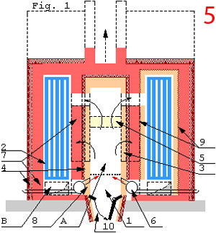
5 Heat transfer from gas to the heat exchanger depends on the square of heat exchange contact and on temperature difference and time of contact; the larger they are, the larger is the heat transfer. The bell can be of any form and volume, into which a heat exchanger can be inserted, i.e. to have a bigger square of the heat exchange. If the heat generator is built in accordance with this principle, the square and the time of contact of hot gases with the heat exchanger is increased, thus the heat exchange improves. The purpose of the convective system of the boiler of periodic action, diagram 5 is efficient and optimal accumulation and transfer of heat energy obtained in the result of fuel combustion reaction to walls 7, air heater of regeneration system 6 (other means of primary and secondary air supply are also available) and water heat exchanger 2, which is placed in it. Heat energy of hot gases is distributed between the walls and water heat exchanger. The more is the temperature difference of gas media and body accepting it, the more energy will be taken in by the body.
Therefore the bell walls shall be massive; they shall get heated slowly and shall be provided with heat insulation 4 outside to preserve heat. This is heat-accumulating boiler. The walls can be made of red brick, single layer (left half of diagram 5) or double-layer red brick with inner lining of fire brick (right half of diagram 5). A thin layer of ceramic material or paper board 9 required for expansion joint compensation of refractory lining shall be laid between the layers.
It is better to use double-layer variant.
Coefficient of thermal conductivity of chamotte brick at 800 degrees λ=1.12, that of red brick λ=0.752 kcal/m*h*degree. Specific heat is equal, C=0.254 kcal/kg*degree.
In this case the chamotte lining of the bell wall gets warm more quicker and to a higher temperature,i.e. the temperature in the bell increases. This provides for a quicker heating of heat carrier in the register to a higher temperature. The same can be said about the walls of the firebox.
The firebox is intended for maximum extraction of energy from the fuel and its transfer to the convective system in maximum amount.
This can be achieved due to increase of combustion temperature at all stages. The temperature of combustion reaction increases if the following is observed:
- The design version of the boiler makes it possible to get a natural zone with an increased temperature of combustion of gaseous constituent of the fuel. This is achieved thanks to the use of «principle of free gas movement", with consideration of the above-mentioned formula.
- Placement of water heat exchanger (cold core) outside the firebox. (It makes it possible to increase temperature in the firebox, achieve complete combustion of fuel and heat water heat exchanger).
- Optimization of amount of supplied air at all the combustion stages. In the West this question is solved due to application of doors with calibrated holes for minimum and maximum air supply as well as using some other means.
- Application of material of walls of firebox 3 with high coefficient of thermal conductivity, which makes it possible to equalize temperature of gas media and the walls quickly and transfer more heat to the bell. For the same purposes mineral wool 4 is also used between refractory lining and the firebox walls.
- Application of combustion catalyst 5 made of material with high coefficient of thermal conductivity.
- Ray heat of catalyst exerts an influence on all elements of the firebox and gas media.
- Usually this is a grate made of chamotte brick which also provides a good mixing of air with fuel.
Regenerative technology (heating of air coming to the boiler using combustion products). This is archived due to construction of regenerator 1 (instead of ash box), ensuring natural heating of air supplied to the firebox by the exhaust gases from the lower zone of the bell (other means of primary and secondary air supply are also available).
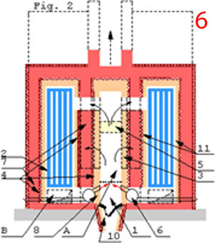
6 In the same way boilers of continuous action are designed, diagram.6. The only difference is in the fact that the firebox is made less powerful and there is no need to make a large heat-accumulating massive in the bell. Redistribution of heat coming into the bell is required. It is required that the walls of the bell accepted less energy and the water heat exchanger- more energy.
This is achieved by making a double-layer wall and putting mineral wool 4 between the layers.
Internal wall 11 (lining), is made of material with a high coefficient of thermal conductivity, for example, of fire brick. From the point of view of construction it is easier to overlap both inner and outer sheath separately.
The lining of the firebox and of the bell will be heated differently and linear expansion. Therefore it is better to span the firebox and the bells separately.
The boiler from the outside can be completely insulated if there is no need to heat the building where the boiler is installed.
The majority of modern boilers working on hard fuel the adjustment of heat productivity is made due to adjustment of air supply required for combustion, i.e. due to the change of combustion power.
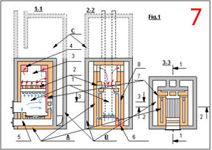
Maximum efficiency of boilers working on any type of fuel can be obtained when they operate (see 7) with maximum power.
At present all the boilers we produce have air supply for combustion in accordance with diagram 7. The holes for secondary air supply we make at the level of fire-door top. This improves the conditions of fuel combustion and improves the efficiency and combustion purity.

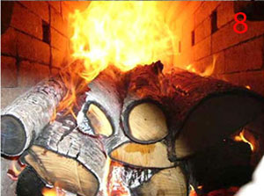
8 From photo 8 it is clearly seen that in high temperature field we have uniform heating of wood and their pyrolysis.
In this case it is seen in what way gasification of wood is made and how pyrolysis gases are burnt. The boiler operates without blasting. Supply of secondary air is made through the holes in the firebox walls.
Efficiency (Performance factor) of such systems of heating significantly depends on the fact at what power the system is functioning. The lower is the degree of the system use the lower is the efficiency and the larger is the fuel consumption. In boilers operating on gas this question is solved. Application of automation allows operation of heating boilers in the same way with maximum efficiency in all modes of operation due to their periodic switch on and switch off. In boilers of continuous action operating on hard fuel this issue can be solved in the following way. Heat coming into the bell is distributed between the bell’s walls and the water heat exchanger. If the time of firing
(combustion) is increased the temperature of the bell’s walls and gas media is equalized and the heat exchange is made practically only due to the water heat exchanger.
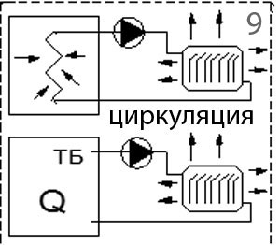
Adjustment of heat supply into water heating system can be carried out due to 9 the change of: combustion power; circulation speed of heat-carrier; redistribution of the way of gas flow movement.
In the first case when air supply to the firebox is reduced, the combustion power is reduced and the boiler efficiency is also reduced which is not desirable. In this case there is no surplus of heat in the boiler.
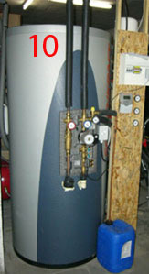
The process is different when the circulation speed of heat-carrier is regulated. When circulation speed of heat-carrier is increased, heat supply to water heating system becomes less as well as heat release from it. 10 In this case no decrease of boiler efficiency is observed when the boiler is operating with full power, but a surplus of heat appears in the boiler, and that heat shall be utilized, otherwise overheating and destruction of boiler is possible. The first indication of increased circulation speed of heat-carrier is a small temperature difference in the supply and return pipe and overheat of the boiler’s walls.
It should be pointed out that this refers only the circuits shown on 9, in which heat exchange (upper) is taking place in the heat source and in the consumer. This is not the case if no heat exchange takes place in the heat source, for example in heat-accumulating tank, (the lower picture).
On photo 10 heat-accumulating tank is shown.
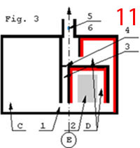
When there is a surplus of heat in the boiler it is possible to utilize it as per the diagram shown in diagram11. The principle of operation of this diagram 11 is as follows. Sensor 6 (diagram 5 and 6), depending on the content of exhaust gases, exerts an influence on the actuating mechanism of the regeneration system air heater 6 (diagram 5 shown on page 5) and optimizes air supply required for combustion. Sensor 5 depending on the temperature of exhaust gases coming out from the chimney exerts an influence on the actuating mechanism of damper 4, opening or closing it.
When quantity of produced and consumed heat is equal hot gases from the boiler through opening1, along the channel and through open damper 4 come out into the chimney. When there is a surplus of heat damper 4 is closed, and hot gases come into heat accumulator D.
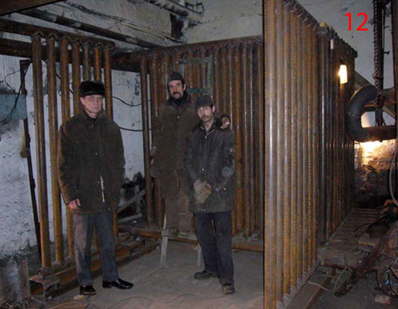
The use of accumulated heat in this diagram is described below, diagram18. It is possible to insert economizer, etc. In accordance with such diagram the heat of exhaust gases from technological processes, for example, heating stoves, etc. Our system of design of heat generators is impossibly flexible and allows designing and construction multifunctional boilers and stoves of any dimension and form with new features and functions.
12 As an example of the flexibility of free gas moving system you may see the heat exchanger of the boiler shown on photo 12 which can be placed inside the bell.
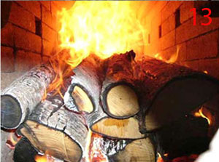
Not the heat exchanger 13 is placed into the firebox but the firebox with dry joint is placed into the heat exchanger. Photo 13 features wood combustion in boiler’s firebox.
For example, boiler can be simultaneously operated with bakery oven (which is not quite good because the temperature in the oven cannot be regulated), as it is done in France, and which has an efficiency of 90% at pure combustion.

Or the boiler can be combined with fireplace 14 with walls being heated, photo14.
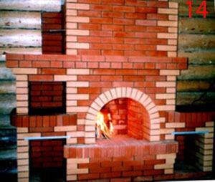
In accordance with such diagram power installations of any purpose can be designed. Electric heaters can be easily installed into the bell, air heater, steam generator or cooking oven, oven for heating stones, technological materials for heat treatment, heating boiler, etc.
Type of wood and especially its moisture exert an important influence on such parameters of boiler as power, efficiency and fuel laying interval. Maximum moisture of wood shall be 25%. The bars shall be properly prepared and charged into the firebox. They shall not be charged in chaotically way or splattered.

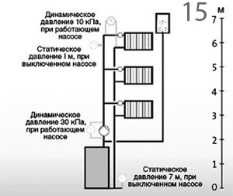
15 Water heating.
Movement of heat carrier in water heating system е is carried out due to creating circulating pressure in the pipes. This can be natural circulation or forced circulation with the help of pump. In the systems with natural circulation preference is given to upper piping of supply pipelines and boiler installation below heating devices, if possible.
The most simple and preferable is the double-pipe heating system with hot water piping under the ceiling and cold water piping at the flow under the heating devices that provides for temperature adjustment in each room with the help of heat regulators on the heading devices. In case of natural circulation heat carrier movement takes place due to the difference of hydrostatic pressures in direct and return pipes. In other words circulating pressure depends on the difference of weight of the column of direct (hot) and the column of return (cooled) water. Therefore, it depends on the difference of density (temperature) of hot and return water and the height of the columns.
Circulating pressure increases if the heating device is located above the boiler. The higher is the device located the greater is circulating pressure for it. Also insulation of direct dropping pipe and return pipelines contributes to the same. Supply pipelines and dropping pipes (with descending flow) ere not insulated.
Here we shall view 2 cases: (This issue refers the design of water heating system and should be solved by the design organization).
1. The center of boiler heating and the cooling center of the cooling device are located at the same level.
2. The center of boiler heating is located below the cooling center.
Complete circulating pressure Рп under natural circulation is made from the sum of pressure that appears during installation of boiler below heating devices Р, and from water cooling in supply dropping pipes Δp.
Рп = Р+Δp. Р=gh(ρо - ρг).
where: h-height of water column (m) between the cooling center of the heating device and the heating center of the boiler, ρо and ρг – are correspondingly density of water cooled after the heating device in return dropping pipe and density of hot water in direct pipe (kg/m³). g-acceleration equal to 9,81 (m/sec²). The center of boiler heating The values of heat carrier density at different temperatures shall be used in accordance with the tables.
The Δp value shall be in accordance with the tables depending on how many storeys are there in the building, line length and the distance between the dropping pipes.
Natural circulation of heat carrier is also provided by additional hydrostatic pressure arising in registers of design suggested by me.
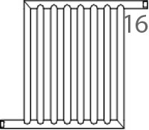
About registers of boilers operating on hard fuel
16 Natural circulation of heat carrier is the most safe and reliable one, as there is no need to rely upon the pump and electricity. It is also the most efficient with regard to heat transfer from boiler to the consumer.
In the system of free gas movement the solution of this issue is ensured by the form of registers of the boiler with several vertical pipes that ensure equal way of heat carrier travel, its slowing down and hydrostatic head in the system (natural pump). Such design provides for: minimal force impact on boiler structural components from register pipes elongation due to temperature impact; small resistance to water movement; good head and their easy replacement.
During system filling with water no air locks arise in the registers if they are installed with gradient for heat carrier flow to the return pipe. Archimede’s force here acts like a motor,in other words hydrostatic head being created in the register.
«Δp=H (ρ_{ret} - ρ_{dir})g where Н-register height (m), ρ_{dir} and ρr_{et} – density of out coming and incoming water in the register (kg/m³), g-acceleration (m/sec²)».
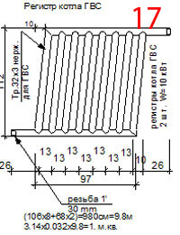
17 The following IMPORTANT factor shall be pointed out. Natural circulation of heat carrier will be in case of continuity of water heating pipes. If non-continuity is observed, for example, in heat-accumulating tank without heat exchanger inside, while connecting direct pipe to the upper zone of heat-accumulating tank and the return pipe to the lower zone, there will be no circulation between the boiler and heat-accumulating tank. The flow energy will be absorbed by the heat carrier, water will boil in the upper zone of heat-accumulating tank and the circulation stops. In order to ensure natural circulation of heat carrier to heat-accumulating tank in this case it is necessary to connect direct pipe to the lower part of heat-accumulating tank and the return pipe –to the upper part. Heat carrier movement inside heat-accumulating tank from direct pipe to the return pipe will be done due to convection (Please refer to diagram 9 on page 8).
It shall be pointed out that on water heating diagrams the conditional connection of boiler to heat-accumulating tank is shown but actual connection shall be made in accordance with the inner design of heat-accumulating tank. The system can be filled with heat carrier both from the upper and from the lower pipe.
The registers can also be made with inclined pipes which create a much stronger head as with direct pipes due to horizontal vector of the head.
When the direct and the return pipes come out to the same side measures shall be taken to compensate temperature expansion of the register. The system can be filled with heat carrier only from the lower pipe in order to avoid formation of air lock in the register.
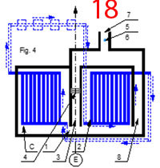
18 Gases leave the boiler with high temperature and take away much heat if they are exhausted directly into the chimney. Because of this one can make a second bell in the boiler near the first one. Usually economizer is installed in it. Economizer is a device for heating the heat carrier which is returned into the boiler with exhaust gases. It is warmed up by the heat of exhaust gases from the first bell. See diagram18 for boiler piping shown on diagrams 5 and 6 and that for economizer. The legend is the same. Dash lines and arrows show conditional diagram of boiler and economizer piping (with natural circulation) and water flow direction. Components and connection of boiler water registers, hot water supply and economizer shall be done in such a way so that water and heat flows were as counterflow process. In other words most cold water shall contact with most cold gases. Further while moving along the register water becomes heated and contacts with more heated gases. This condition is met to a greater extent if the boiler is made in a version of a bell in which in each section lying higher the temperature is getting higher. At such opposing flow of water and gases (heat flows) between them temperature difference between them is preserved which is required for heat transfer; the probability of water vapours dropping out that cause pipe corrosion is reduced. This is especially important if wood containing a lot of water vapours is used as fuel. Such movement of water and gases is called counterflow. Heat carrier shall undergo chemical water preparation to neutralize harmful salts. Therefore register accessories shall provide a possibility of periodic water discharge from the register into water heating system. This is required for periodical burning-out of register dry pipes of soot through a special sealed door in the bell where they are installed or a possibility of their removal from the boiler for repair.
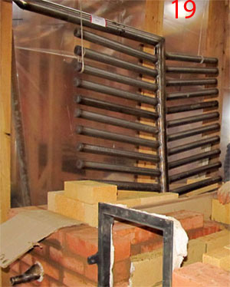
19 This photo features a developed heat-exchanging surface. My application for an invention is RF No. 2008144271 «Developed heat-exchanging surface». Diagram 20 features heat-exchanging surface in operating position. The developed heat-exchanging surface consists of heat exchange surface 1 and a system of hollow rods 2 located in holes of heat exchange surface 1 sharp angled to it. Butt ends of rods 3 from the side if heat supply is plugged.
The developed heat-exchanging surface operates in the following way. On the left side from the surface of heat exchange there is a heat supply system filled with warm gas. On the right side there is a system of heat release filled with liquid being heated under pressure Р₁. In hollow rods there‘s also liquid being heated.

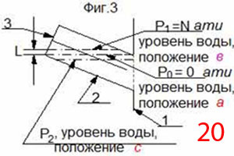
20 While filling the heat release system with liquid air cavities are formed in the hollow rods. Boiling starts when pressure of saturated vapour over the water surface in the hollow rod becomes equal to pressure in the cavity. When pressure in the cavity increases the temperature of liquid boiling also increases. To maintain boiling heat shall be supplied to liquid that shall be used for vapour formation and vapour functioning against external when the volume of vapour phase is becoming larger.
When pressure in the cavity equals to atmospheric pressure (pressure over the pressure gauge Р₀=0 _{atm}), the liquid level occupies position а. When pressure in heat release system increases until it gets the value Р₁=N _{atm} the volume of air cavity in the hollow rod becomes less, the level of liquid increases until position в. When heat is supplied from the side of hollow rods, liquid in the hollow rods begins to heat rapidly due to large surface of heat exchange, presence of evaporation surface and low quantity of heat carrier in them. The heat carrier located inside hollow rods 2 actively warms up and vapour comes into the cavity. This vapour creates in the cavity excess pressure Р₂, that is larger than pressure Р₁ in the heat release system, Р₂> Р₁ or Р₂ > N _{atm}, which causes an increase of temperature heating the liquid and volume of air cavity, lowering of liquid level in the hollow rod until position с, ejection of vapour from it into the heat release system, i.e. release of heat with vapour from hollow rod cavity into heat release system takes place where the vapor gets condensed. After vapour is released pressure in the cavity decreases (equalizes until pressure value equal to Р₁ in heat release system). This is a cycle process: pressure increase, then decrease, etc. or cycle increase or decrease of cavity volume. After vapour release and pressure decrease in the cavity the volume of the air cavity becomes less due to coming of cold water into the hollow rod from the heat release system. With pressure increase in hollow rod cavity the pressure in heat release system also increases (the principle of hydraulic jack) and as consequence, the temperature of water boiling gets higher. An intensive heat release from the heating surface prevents harmful mode of film boiling. Heat release in mode of nucleate boiling increases heat transfer into the heat release system.
For specifying the required capacity of boiler/stove (heat generator) to be used for house heating there exist approximate common values of specific power as per climatic zones:
for Moscow region - W sp. = 1,2 - 1,5 kW;
for northern area - W sp. = 1,5 - 2,0 kW;
for southern area - W sp. = 0,7 - 0,9 kW.
Power calculation of boiler /stove (W boiler) is made in accordance with the formula:
W boiler = S W sp. / 10, where S-square of the house; W sp.- approximate required power for heating of 10 sq.m of the house as per different climatic zones; W boiler- required power of heat generator for heating the house per hour.
That means that the accepted hourly heat losses for calculation per 1 m² of the house square make: 120-150 W; 150-200 W; 70-90 W as per specified climatic zones. If you multiply these figures by your house square you will get the required hourly power of the heating device (heat generator). At present hourly heat losses are quite large and require large expenditure for construction and operation of heat generator. This expenditure for construction and operation will be less if the house will be heat insulated up to 70 W/m² and less.
Boilers of continuous and periodic action
It is necessary to foresee a special device in the boiler that controls the boiler and protects it from condensate which will be mentioned below.
For heating public and industrial houses very often boilers of continuous operation are used. Service personnel are required for their operation.
The system of heating of boilers of continuous operation shall be designed with the use of heat-accumulating tank because it provides for better boiler operation and increases its efficiency. Using the boiler of continuous operation it is possible to heat heat-accumulating tank of large volume. Adjustment of heat carrier temperature in heating (direct) circuit by the personnel due to the change of combustion power will lead to decrease of boiler’s efficiency. It is better to adjust the degree of heating of heat-accumulating tank firing the boiler at full power stopping it periodically.
Before stopping the boiler it can be heated much more by increasing the circulation speed of heat carrier between the boiler and heat-accumulating tank.
In case of using water heating system without heat-accumulating tank temperature adjustment of heat carrier can be done due to the change of heat carrier movement speed. Heat transfer depends on time of contact of heat-exchanging surfaces. When the heat carrier circulation speed is increased the supply of heat ton water heating system is decreased as well as heat emission from it. In this case no decrease of boiler’s efficiency is observed if the boiler operates at full power but a surplus of heat appears in the boiler that has to be utilized, otherwise overheat and destruction of boiler is possible.
In my opinion, it is better to control the degree of boiler heating by observing the temperature of the exhaust gases from the first bell. Permissible heating temperature can be determined during laboratory (experimental) tests.
The first indication of increased circulation speed of heat-carrier is a small temperature difference in the supply and return pipe and overheat of the boiler’s walls.
By decreasing the circulation speed of heat-carrier it is possible to use the excessive heat accumulated in the boiler.
Excessive heat can also be used due to application of the second circuit (bell) where it is possible to place the register of hot water supply or other consumers of heat.
Water heating system for boiler of periodic action operating on hard fuel 21
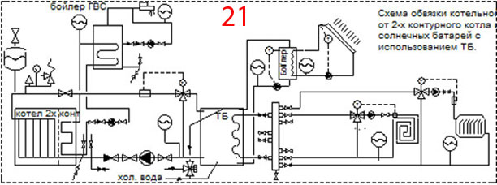Water heating system of boilers operating on hard fuel meeting the present time requirements consists of: heating circuit (left half of the diagram) and secondary circuit (right half of the diagram).
Heating circuit: single-/double-circuit with protecting group, hot water supply, condensate protection, pump with accessories and expansion tanks. Secondary circuit: heat-accumulating tank, hot water supply system from solar panels, supply manifold and mixing circuits of different purposes.
For additional information please refer to the article «Automation of boiler houses» (weather dependable heating systems) http://www.ivd.ru/document.xgi?id=4846&gid=106&oid=142
Very simple the issue of piping for small-size boilers of periodic action with single type of high-temperature heat exchanger (radiator) is solved. Adjustment is made due to 1 - 2-time firing, and also during firing. In this case after finishing firing of boiler the temperature of heat-carrier decreases sharply and further it decreases fluently until next firing due to the heat accumulated by massive of the boiler. Therefore the boiler shall be heat insulated and besides, it shall be binded with angles and band from all sides.
During boiler test in Polushkina on 12.02.10 we took measurements which showed that heat exchange through the boiler’s walls approximately equals to heat exchanger through the heat exchanger. This is heat-accumulating boiler which during firing time shall accumulate together with heat-carrier of water heating system such quantity of heat that will compensate hourly heat losses of the building. Balance calculation has to be done. Hourly heat productivity of the boiler shall be regarded together with hourly heat losses of the building.
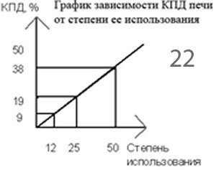
22 When making a design of water heating system with a boiler operating on wood (hard fuel) one must always study the issue of ensuring the most efficient performance factor of energy extraction from fuel and most efficient performance factor of use of released energy.
This is quite complicated because the adjustment of combustion power in boilers operating on hard fuel is carried out by means of changing the quantity of air supply which is bad. A good heating system shall operate effectively in quite a large area of heat power, i.e. in a wide range of outside temperature.
However the efficiency of modern hard-fuel heating systems depends to a large extent on the power with which the system is functioning. The lower is the degree of the system use (heat power of the system is 12 kW but only 3 kW is used), the lower is the efficiency and the larger is the consumption of fuel. The results of research performed by Finnish specialist (Kari Mäkelä) show that if the selected heating system for house heating has power, for example of 12 kW and 75% efficiency but only one forth of the power is used (3 kW), its efficiency will be only19%. Therefore fuel consumption is 5 times more then theoretically required. Please refer to diagram 22, which Kari Mäkelä provides.
Due to this boilers/stoves shall have less power but in most cold period they shall be fired 2 times. There are also other means of increasing the efficiency of operation of stove heating. Forя water heating only modern system of heat adjustment is capable of significant reduction of costs and formation of favorable temperature conditions in the house. Obtaining the most effective efficiency of energy extraction was viewed previously and can be ensured only under condition of boiler operation at full power.
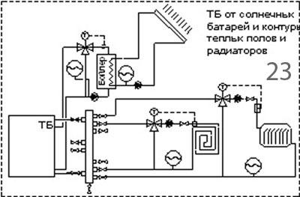
23 Effective efficiency of use of extracted energy can be obtained only in the case when there is a heat-accumulating tank installed in water heating system and automation means are used. Possibility of smooth adjustment of temperature in the circuits is ensured by heat-accumulating tank of large volume and mixing circuits for selecting the heat-carrier in them with required temperature.
This is the most rational variant. Maintenance charges for heating are significantly reduced and quickly pay off the cost of installation of heat-accumulating tank. The boiler piping system can have several circuits. As a rule, this is a heating circuit from the boiler to the heat-accumulating tank and high-temperature circuit of hot water supply system, diagram 24. It is connected to boiler heating circuit. Water is heated in hot water supply boiler up to 65 °С.
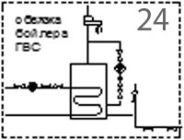
24 Water temperature in heating circuit is achieved due to the boiler operation and depends on the time of its operation.
There are two or several mixing circuits reducing the heat-carrier temperature due to automation application, from heat-accumulating tank. In the mixing circuit the temperature of the heat-carrier is determined by the temperature in the heat-accumulating tank and by the position of damper of the actuating device, two-way or three-way distribution valve with heat regulator (or with servodrive). Nearly always there is one or several circuits of radiant heating. It is advisable to use low-temperature mode of heating with the temperature in supply line within 45-50 °С. In other words, using common devices to be used for application of low-temperature heat-carrier. This makes it possible to increase the time of using heat-accumulating tank without heating the boiler.
This also leads to a more comfortable perceiving of heat radiation by a man. There may appear a case when there is a necessity to reduce temperature in a certain part of the house when at a given moment nobody lives in it.
Or warm floor that requires its own mixing circuit. Many consumers order
additional installation of one or several circuits of warm water floor. These are low-temperature systems with changing temperature in the supply line (30-55°С). In all these cases mixing circuits have to be designed for decreasing heat-carrier temperature.
Each circuit shall be provided with expansion tank on the return pipe till circulating pump directly connected with the heat producer and heat-carrier circulating system. и Diaphragm expansion tank is located on the intake side of the circulating pump; this minimizes the danger of vacuum formation.
Water heating system shall be suitable for the type of fuel used in boiler. The systems with boilers operating on wood the issues referring adjustment are solved especially difficult. Design and carrying out jobs regarding water heating systems shall be entrusted to qualified personnel. At present however, educational establishments of higher learning in Russia do not prepare specialists in this field who can design hard-fuel boilers of free gas movement system as well as water heating systems for such boilers.
Liquid-type heat-accumulating tanks
During combustion of wood within a short time of heating a boiler a lot of energy is extracted. It shall be preserved and then used in an optimal way.
For this purpose heat-accumulator is used. Heat-accumulator is a storage-volume from all sides insulated with polyurethane 80-100 mm thick into which several hot water supply heat exchangers can be installed. Heat-accumulator can have a heat exchanger for geothermal heat pump or solar collector. From it one can use so much heat as is required at a given moment.
The quantity of accumulated heat Q (kW/h*) shall be more than the heat losses of the building. Q=c*V*^{о}C, where c –calorific capacity of water - 1.17 W*h/kg*degr.,
V –water volume (kg), ^{о}C=50 degrees, calculated temperature difference of water heating. One can select the volume of heat-accumulating tank and power of wood boiler in such a way that it would be possible during 1-2 firing to accumulate the amount of heat required. If heat-accumulating tank has a volume of 2.5 m³ (2500 kg) and is heated to temperature difference of 50 degrees, it will accumulate heat: 1.17 W*h/kg*degr * 2500 kg * 50 degr.= 146 kW*h. If we subdivide the accumulated amount of heat by hourly heat losses of the house we will get the amount of hours during which it can be heated from the heat-accumulating tank. If one takes into consideration actual heat losses at a given period of time, this time will be much more. If the accumulated heat is divided by the boiler power we will get the amount of time in hours the heat-accumulating tank shall be heated.
It is advisable to have larger overall dimensions of heat accumulator than the conservative values. Heat accumulator with high temperatures has a larger temperature range of operation if the heating system is designed for low-temperature heat carrier.
The most complicated and not so well studied is the task of connection to heat-accumulating tank as heir design version and their purpose have a lot of varieties. As heat-accumulating tanks one can use capacitive water heaters for hot water preparation in which in their lower part heat exchanger is available. During connection of heat-accumulating tank or boiler from the side of heating circuit one should observe two rules:
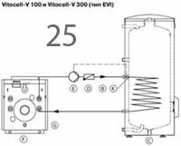
- 25 If he connection is made through the heat exchanger, then the direct pipe shall be connected to its upper branch pipe and the return pipe - to the lower one. Heat- carrier movement in the pipe of the heat exchanger and hot water in the heat-accumulating tank shall be counter-flow. That means that most hot water in the heat exchanger contacts with most hot water in the heat-accumulating tank which is shown in diagram25.
While water cools down most cold water in the heat exchanger contacts with most cold water in heat-accumulating tank; temperature difference between them shall be constant.
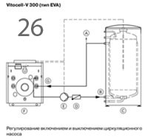
26 2. If there is no heat exchanger in the heat-accumulating tank, the direct pipe shall be connected to the lower zone of heat-accumulating tank, and the return pipe – to the upper zone, which is shown in diagram 26.
That is natural water circulation in the heat-accumulating tank and forced circulation in boiler circuit shall be in the same direction. It shall be pointed out that in registers of our boilers hydrostatic head is created due to their larger height. Therefore contrary to the boiler shown in the diagram in which circulation of heat-carrier is carried out with pump, we have natural movement of heat-carrier without pump. Connection of heat consumers in both cases shall be carried out in the upper zone of heat-accumulating tank; in this case the intake of heat-carrier shall be in the upper zone and higher than the return water.
Here the rule shall be observed according to which movement of flows shall be in the same direction.
27 Some design variants of heat-accumulating tank.
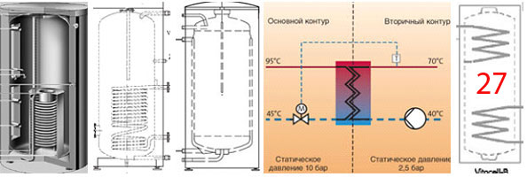 Boiler control and condensate protection
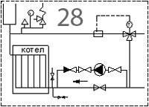
28 Diagram28, features organization of natural or (forced circulation) of heat-carrier with pump on by-pass line). The boiler has an expansion tank, device of boiler safety and the device for filling the system.
The heat-carrier circulation shall be developed natural, without pump.
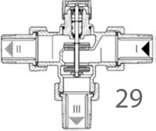
Boilers shall be provided with condensate protection. It is advisable to use automation for temperature adjustment of water heating at the output. Automation shall provide organization of water movement over the small circle (direct - return pipe) until the temperatureдо of water heating at the output reaches 45-55 ^{о}С; after that water shall flow over the large circle. Otherwise 29 condensate appears on the registers and operation of boiler becomes worse (condensate water comes to boiler in a great amount «by bailers»).
For adjustment one can use three-way distribution valve Oventrop shown in diagram 29 that ensures continuous or two-position mode with heat regulators or servodrives. It has two inputs and one output. The running fluid is distributed in accordance with the position of valve plate.
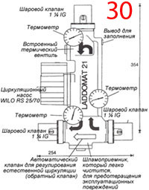
For continuous adjustment heat regulators are used with tank side transmitter (or with 30 immersed) transmitter. These proportional regulators operate without additional energy and can occupy intermediate positions. If temperature is increased on the sensing device, direct pass through will open, and the side pass through closes.
For standard two-position adjustment thermoelectric servodrive is used. Working element of the servodrive is аn elastic material heated by electricity.
Three-way distribution valve shall be readjusted for another opening and in some other solution where it is used.
Other solutions for « boiler control and condensate protection» are also available; refer to diagram 30, for example, Laddomat 21. It is installed on the return pipe before the boiler and ensures circulation of heat-carrier in the required direction. It is provided with its own circulation pump, built-in thermal valve with heat regulator, automatic valve for natural circulation adjustment and ball valves.
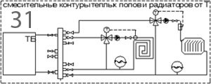
Mixing circuits for heat-carrier temperature decrease 31 Heat-carrier temperature decrease for low-temperature heat exchanger, including heating radiators aimed for low-temperature heat-carrier can be done by using a mixing circuit with controlled three-way distribution valve described above. The mixing system is connected to heat-accumulating tank and consists of independent circuit with its own pump, three-way distribution valve with heat regulator or servodrive, return valve, temperature transducer, expansion tank shown in diagram 31.
Mixing circuits shall be connected to heat-accumulating tanks, not to hard-fuel boiler.
The principle of operation of mixing system is the following. When the temperature of heat-carrier increases above specified value on sensing device a side pass through of the distribution valve opens and the direct pass through closes. Heat-carrier circulates (for example, along the warm floor circuit) without inflow of hot heat-carrier from the heat-accumulating tank. If the temperature decreases below the specified value, the side pass through slightly opens and direct opens a little, and the heat-carrier circulates through the heat-accumulating tank. Other solutions of «mixing system» are also available. On heating radiators, distribution collector of warm floor system separate thermostatic valves can be installed with thermostatic heads, which function is to change the consumption of heat-carrier through them, i.e. the function of temperature regulation. The warm floor surface temperature in living rooms shall not exceed 28^{о}С. Besides, it shall be uniform over the whole floor surface. These limitations as well as limitations of temperature expansion of concrete bars of warm floor and pipes embedded has determined maximum temperature of heat-carrier supply to warm floor circuit. It is considered that temperature in the warm floor supply pipe shall not exceed 50^{о}С. But, as a rule, it doesn’t exceed 45оС.
If the heating system consists only of warm floor it is required to decrease temperature of heat-carrier supplied to the warm floor; in t is case the heat-carrier temperature at the boiler output shall be maximum, i.e. the boiler shall be fired at full power. This is possible only in a variant when the heating system is provided with heat-accumulating tank. In case of using only low-temperature heat exchanges for heating the system shall contain heat-accumulating tank.
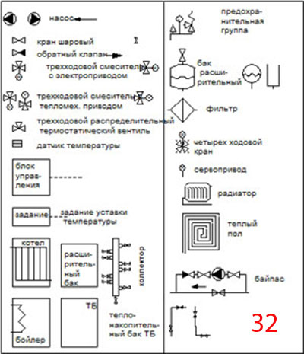
32 Heating system that is provided with heat exchangers with different temperature parameters shall also be designed with heat-accumulating tanks. The boiler always operates at full power and heats the heat-carrier in the tank. From the tank the heat-carrier is supplied for heating and to warm floor over its own independent circuit with its own pump having its own parameters.
It is possible to design hot water supply system from double-circuit boiler or use a mixing circuit of hot water supply boiler from the boiler which is parallel to heat –accumulating tank circuit. The temperature of heat-carrier in it shall not exceed 65оС.
Legend on the diagrams

I. V. Kuznetsov
Ekaterinburg
tel (343) 3077303
e-mail: igor@stove.ru
http://stove.ru
http://kuznetsovstove.com/ru/
http://stovekiv.com/ru/

21/09/2017 © Igor Kuznetsov "Kuznetsov's stoves"

