Household stove systems, their features and differences
To understand the function of different systems let’s regard some definitions first. The stove consists of the following basic parts: firebox with an ash box and a convective system, consisting of horizontal and vertical channels, bells and smoke chambers. The convective system is a tool for utilization of extracted thermal energy, which can be used for heating a boiler, a heating unit and heat-accumulating massive, etc.
The chimneys in all the stoves according to their functional purpose are the same. At the present time all the stoves being built may have the following convective systems:

Fig.45 Convective systems of stoves:
- serial; b) parallel; c) channelless (bell-type); d) combined; e) with air chamber
1- monoreversible, 2- double-reversible, 3-multireversible, 4-air chamber

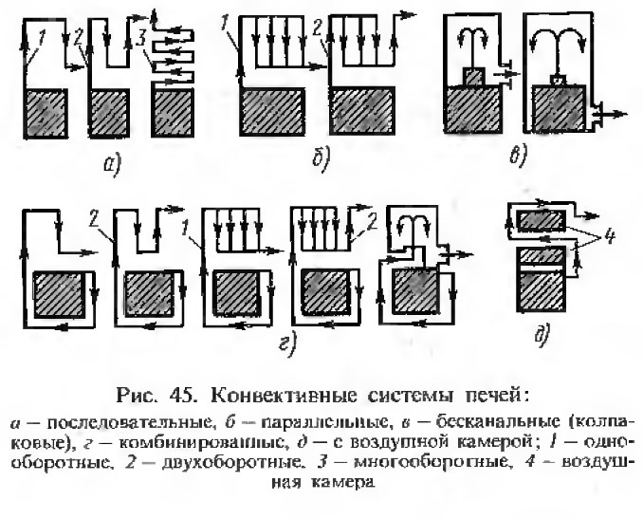

The stoves using forced gas movement system
In Fig. 45 (А.Е. Shkolnik, Stove heating of low-rise buildings) the basic convective systems of stoves that have been used all over the world for centuries and still used at present are indicated. The stoves with indicated convective systems refer to “forced gas movement systems”). The main feature of a stove with forced gas movement system is lack of gas separation with regard to heating degree in the firebox. To the convective system come gases mixed with ballast gases. For example, stoves of I.S. Podgorodnikov cannot be referred to “free gas movement system”.
There are vertical channels, upward- and downward-going channels. Over the upward-going channels the gases rise up. Over the downward-going channels the gases move down. Over the horizontal channels the gases move to the left or to the right. The bell is used in the case when the gases, come in and go out from below. Smoke chamber is used when the gases from one source or several sources go inside or outside from below and come out into one channel in the upper part. In this case the opening hole for gas to come out from fireplace or chargrill is not above the hole from which the gas comes out from the smoke chamber.
How and due to what smoke gases move in the indicated parts of the stove?
In the upward-going channel two forces directed upward are acting. These are chimney draft and Archimedes force of hot gases. The chimney draft along the channel section is uniform. Should the gases in a certain place of the channel section be hotter, in this case the summed-up force is larger, and the gas flow is distributed ununiformly along the section, and is in this place larger. That is to say if we make a channel with a larger section, the corner of the stove, in which the channel is situated, will not get heated. Due to that reason the people make the channel of a smaller section, taking into account that the smoke gas velocity should not exceed 5 m/s, otherwise the stove will be smoking. In the upward-going channel there is no place for placing a heat exchanger.
In the downward-going channel the gas flow is distributed uniformly along the section. This phenomenon is called “self adjustment” and is explained by the fact that the impulsive forces of gases, draft and the Archimede force of gases are directed to different sides. The draft is directed downward and the Archimede force of gases – upward. Should in some place of the horizontal section of the channel the temperature of the flow be higher,the Archimede force in this place is higher. That means that in this place the brake force increases, and the flow is distributed to place in which it is easy for it to run.
In horizontal channel the gases move due to the chimney draft. In channels with large section the gas flow takes place in the upper part of the channel.
When the gas flow moves over the channel of the convective system of any type due to the chimney draft the following takes place:
When the channel section is decreased the gas flow becomes thickened, its speed, energy (temperature) increases and, as consequence the heat exchange increases, that is the channel is getting heated higher. In the forced gas movement system the gas particles fly with high speed over the heat exchanger surface of the convective system due to the chimney draft. However, in this case the friction force of the flow increases resulting in appearance of noise during its movement, and finally, the channel cannot pass through the whole volume of gas arising during combustion. It should be pointed out that this refers the case when the gases from the firebox are running one way. Should other ways exist, the gases are running by the way easier for them to run, and in this case in channel of smaller section nothing from described above happens. For example, if the firebox is provided with two exits, it is not permitted to decrease the channel section under the hearth as the hearth is not heated to the required temperature. In case of channel of large section, the flow is diluted, its speed, energy (temperature) decreases. In this case the heat exchange processes take place when the temperatures of the flow are low. In this case the stove will heat up badly.
In case of large sections of downward-going channels in the system of forced gas movement the gas flow is distributed uniformly over the section, its temperature decreases, the flow runs due to the chimney draft and its heat is poorly accumulated in the channel. In accordance with this principle the counter flow stoves are being built, which are very popular in the West. In such convective systems the heat exchange is ineffective. In such channel it is not possible to install a heat exchanger to be efficient.
A separate group is made up by “bell-type” stoves, proposed by Academician, Professor V.E. Grum-Grzhimailo and I. S. Podgorodnikov, Phd. Please refer to Fig.45 в. Those are stoves of forced gas movement system, but not the stoves proposed by me, using the system of free gas movement system. The difference between them is in the fact that in their firebox the gases are not distributed in accordance with their heat degree. The convective system incorporates gases, heat carriers mixed with ballast gases.
Combustion is a chemical reaction during which from simple matters, carbon (С) and hydrogen (Н₂), in combination with oxygen (О₂), other matters are formed with heat release. When we heat fuel it is divided into volatile part consisting of carbon and hydrogen and solid residue, carbon. The volatile part is called hydrocarbon.
Combustions processes can be expressed with the help of chemical equations showing in what proportions and how simple matters react.
If air is used as oxidant, during efficient combustion, the output is carbonic acid (СО₂) from carbon, and water vapours (Н₂О) from hydrogen. These are heat sources formed in the result of chemical reaction of combustion. Besides, there is nitrogen as a component of the air used for combustion which represents 4/5 of the output volume. Actually, due to the unequal mixing of the carbohydrate with air, air has to be supplied at a rate of 1.6 to 2.4 times the theoretical amount required (excess air coefficient). Therefore, there is always a surplus of air with increased nitrogen content in the firebox that did not really take part in the combustion process plus the water vapours from evaporation of water normally present in fuel. All these gases are ballast gases, that is, they do not take part in combustion but only get heated from the combustion of carbon and hydrogen. In other words, they reduce the useful heat. The molecules of the above-mentioned gases are totally independent, that is they are not coupled with each other.
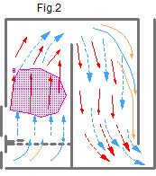
The stoves of forced gas movement, Fig.2 have one feature in common. In the combustion chamber combined with convective system movement of gas flow formed during fuel combustion is made due to chimney draft. The products of combustion reaction are mixed to form a single flow. All these stoves are based on forced gas movement.
In their firebox the gases are not distributed in accordance with their heat degree. The convective system incorporates gases, heat carriers mixed with ballast gases. On part of the gases are heat sources, another part is heat consumers. They get mixed in the flow, their temperature decreases,the conditions of fuel combustion become worse. The cooled flow passes through the channels with great velocity due to chimney draft, the extracted heat is used inefficiently. The stoves of forced gas movement are characterized with poor extraction and use of extracted energy. Such fuel combustion method has been used for thousands years.
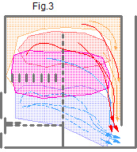
The primary task is to make the fuel combustion conditions better. The gas flow shall be subdivided. The gases used as heat sources shall be used efficiently. Ballast gases that consume heat shall be extracted from the stove, cooling it down very little. The amount of water vapours coming out from the chimney shall be reduced as they take the heat spent on their heating away. This shall be done using laws of nature.
The gases can be subdivided only at the stage of their formation.
The stoves of new system of free gas movement built in accordance with my patents of the Russian Federation for invention: No. 2055272 dt. 27.02.1996 and No. 2553748 dt. 22.05.2015, METHOD OF FUEL COMBUSTION.
These stoves have a combustion chamber combined with convective system. Movement of the gas flow arising during combustion process occurs due to heat exchange processes when blast and draft are equal. Fig.3

The first step in creation of FREE GAS MOVEMENT SYSTEM
The stoves in which “the lower level and the firebox are combined to form a single space through a vertical crevice,2-3 mm width (hereinafter referred to as dry joint), creating a lower bell” in accordance with the patent of the Russian Federation No.2055272. The system of Free gas movement is characterized by extraordinary flexibility.
Such design makes it possible to create in the firebox and convective system the conditions of bell in which movement of gases corresponds to their natural strive: hot gas rises up and the flow of cooled gas goes down only due to heat exchange processes (when blast and draft are equal). Through the «dry joint» an intensive heat exchange from the firebox to the bell due to convection and diffusion, without chimney draft. There will be no vertical vector of chimney draft. Functioning of the dry joint can be traced in the following example. If you open a window or an outside door by 2-3 cm in winter an intensive heat exchange will take place. The greater is the temperature difference inside the house and outside, the greater will be the heat exchange. A question to listeners. In which cases the dry joint shall be made larger or smaller?
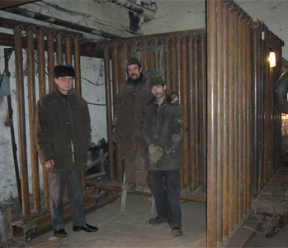
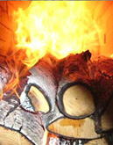
This made it possible to create thousands of new designs of highly efficient household stoves and boilers of different functional purposes. There is a possibility of creating numerous heat generators of different capacity and functional purpose with new functions useful for people, including industrial-type heat generators.
The flexibility of free gas movement system can be seen from the boiler heat exchanger which is inserted in the bell (see the picture above). Not the heat exchanger is placed into the firebox but the firebox with dry joint is placed into the heat exchanger. Combustion in the boiler firebox is shown in the picture. In accordance with such scheme the drawings of stoves are available for free access; please refer to http://stove.ru . They have good callbacks with regard to efficiency. Its drawback is poor combustion of volatile gases.
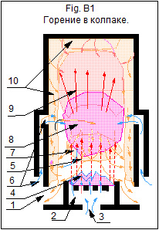
The Second step in development of free gas movement system
Patent of the Russian Federation for invention 2553748 dt.22.05.2015 METHOD OF FUEL COMBUSTION.
Let’s view the process of fuel combustion in the bell, please refer to Fig. B1
The bell is a vessel turned upside down. 1- exit of gases from the bell (no draft); 2- ash box; 3- primary air (PA); 4- fuel; 5- hydrocarbon; 6- secondary air (SA); 7- harmful ballast gases; 8- zone of combustion reaction; 9- useful products,- СО₂ and Н₂О; 10- heat exchange zone;
If we burn wood at the bottom of the bell on the fire bar (Fig. B1), volatile inflammable gases are produced. They consist of a mixture of carbon-С and hydrogen-Н₂. If we supply secondary air to them combustion reaction will take place at high temperature. The reaction can be expressed by chemical equations.
С+О₂=СО₂+7940 kcal/kg С, - formula 1,
Н₂+1/2О₂=Н₂О+2579 kcal/Nm³ Н₂ , - formula 2
The proportion of matters taking part in chemical reaction is maintained as well as their content. Carbon- С and hydrogen- Н₂, react with oxygen - О₂ in quantity determined by the chemical equation. Other matters cannot take part in this reaction.
As a result of the reaction we get combustion products which are subdivided in accordance with heat degree. Under the bell conditions hot particles, hot carbon dioxide and water vapours rise upward. The ballast gases go down and are extracted from the bell through the zones near the heat exchange surfaces. The gas flows due to heat exchange processes, without chimney draft.

.
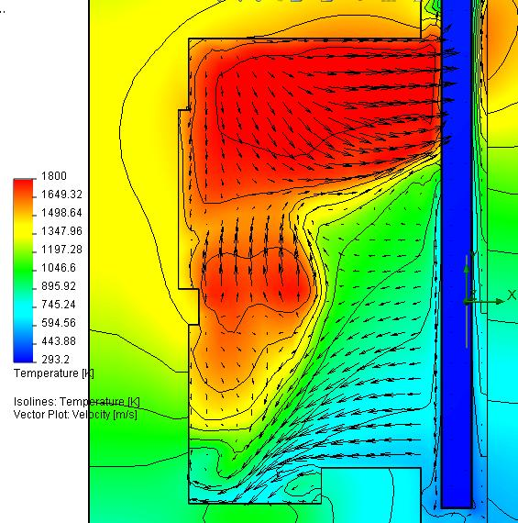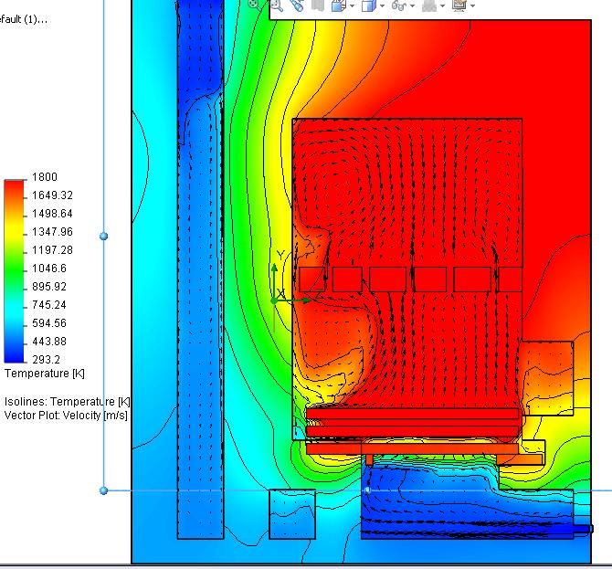

This is confirmed by research made by Ukrainian researchers, Professor, Ph.D I. V. Kazachkov and Yu. N.Kamaev, assistant professor, Kiev polytechnic institute. They carried out experiments connected with research of heat exchange processes and calculation of heat balance of boiler КIК 17 using software programs Solid Works and FloWorks. Convection movement of heat flows through dry joint from the firebox to the bell of hot gases is clearly seen on the thermograms of cooled gases to as well as return и возвращение охлажденных газов to the lower part of the firebox (please refer to the left thermogram). You may also see movement of hot particles in the firebox upward along the center of the flow as well as cooled down particles along the walls of the firebox (please refer to the right thermogram).
Taking into consideration* of physical and chemical phenomena in the process of combustion the scientists carried out research of heat-hydraulic processes of gas movement in assumed stationary heat source instead of real combustion process (the heat source is constant, 15 kW.
During fuel combustion in free gas movement system movement of cooled down combustion products СО2 and Н₂О in the firebox and also movement of ballast gases is directed downward close to the walls in zones with lower temperature. Movement of initial substances (hydrocarbon) is directed upward over the center of the firebox. Turbulent movement takes place in the contact zone of the moving flows. The process has a heterogeneous character, and the time required for passing the diffusion stage is reduced. The necessary substances are available and now arise the conditions during which “reducing and oxidizing chemical reactions take place” during reaction with carbon with appearance of air gas as per reaction С+О₂=СО₂; 2С+О₂=2СО, water gas С + Н₂О = СО+Н₂; С + 2Н₂О = СО₂ + 2Н₂, steam-air gas; along with reactions during which air gas is formed there are also reactions during which water gas is formed. The reducing reaction also takes place during interaction with carbon of carbon dioxide as per the formula СО₂+С=2СО with receipt of carbonic oxide- fuel gas. (3). The gases are burnt and additional heat is produced. No heat is used for water vapor formation. The difference of particle concentration is the driving force of diffusion processes to transfer the substance from one phase to another.

During fuel combustion in the bell the energy of hot gases is accumulated, concentrated and used in the bell. Only cooled down gases can be extracted from the lower part of the bell. The bell can be of any form and volume. In this case one can speak about the heat content in the fuel when it is oxidized by pure oxygen. By analogy of acetylene combustion with pure oxygen from the bottles. At present the value of the heat content in the fuel is indicated when it is oxidized by the oxygen present in the air, that is with nitrogen, a ballast gas. This is the extraordinary efficiency of heat extraction and use of extracted heat. In accordance with this scheme the stoves and multifunctional complexes are made, please refer to http://kuznetsovstove.com.
Features and possibilities of stoves of different systems
STOVES OF FORCED GAS MOVEMENT IS THE PREVIOUS LEVEL OF TECHNIQUE
During long previous years the design of energy plants using the system of forced gas movement system with regard to heat technology has been developed to a maximum possible level and cannot be improved any longer.
- The stoves of forced gas movement system cannot satisfy the ever increasing needs in multifunctional stoves and boilers of different capacity and cannot meet the customers’ requirements.
- The combustion reaction results in appearance of heat-carriers carbon dioxide (СО₂) from carbon and water vapours (Н₂О) from hydrogen, as well as conditionally cold ballast gases. They are mixed in the firebox of stoves of forced gas movement system; the temperature of the gas flow decreases, the conditions of fuel combustion and the use of the extracted heat worsen.
- The forced gas movement stoves have no place for placing a heat exchanger.
3.1 The heat exchanger in the firebox reduces the temperature and the combustion conditions get worse.
3.2 In the upward-going channel of large section the gas flow is distributed nonuniformly.
3.3 In the downward-going channel, for example, in counter flow stoves, the gas flow is distributed uniformly along the section. The gas flow is “smeared” along the section; its temperature becomes lower; it constantly moves, and the heat exchange worsens.
- The cooled down flow is running through the stove channels upward, downward, left and right with high speed; the time of contact shortens, that means that the gas heat exchange with heat exchange surface worsens.
- In view of the above reasons it is not possible to create a great number of multifunctional stoves of different capacity in the system of forced gas movement, though the demand is ever increasing. The same reason prevents creation ecologically friendly boilers of different capacity. Due to this the construction of boilers on solid fuel is prohibited by law in North America.
- Heating of the first and the last channels is not uniform. Due to this there exists a great danger of crack formation on the stove.
- It is difficult to control the time of stove firing and the time of closing the damper. If one closes the damper too early, one can get carbon monoxide poisoning. If you forget to close the damper in due time the stove will cool down quickly. That means one may have great heat losses if the damper is not closed in due time.
- The combustion products are usually extracted at such high temperature that water contained in this product is usually present in the form of vapour. In this case water vapours don’t give up heat spent during combustion for evaporation of water, and it gets lost. When the gas temperature is below 100 ^{о}С condensate is formed and as a result the chimney is destroyed.
- At the finishing stage of combustion when charcoal remains in the firebox the concentration of СО increases. Due to lack of oxygen incomplete combustion takes place. This is explained by the fact that air in forced gas movement system in the firebox comes out vertically upward due to the chimney draft and exerts a small influence on carbon (charcoal). Due to this reason during the stove test for ecology this period is not taken into account. However carbon dioxide during this period comes out from the stove. Nobody seem to notice it!
Stoves of free gas movement system, NEW LEVEL OF TECHNIQUE
The system of free gas movement enables creation of a great number of heat generators of different capacity and purpose (including those of industrial type) with new functions useful for people.
Distribution of gases takes place in the firebox. The combustion products are subdivided in accordance to heat degree. Hot particles, carbon dioxide and water vapours rise upward where they are used effectively. The ballast gases go down. Extraction of ballast gases from the combustion zone contribute to increasing the efficiency factor of energy extraction from fuel and use the extracted heat efficiently.
The heat generators are provided with space for placing the heat exchanger. The heat exchanger is placed in the bell. The fuel in the firebox is burnt efficiently, and the extracted heat is used efficiently in the bell.
During fuel combustion in the bell the energy of hot gases is accumulated and concentrated in the bell. Only cooled down gases can be extracted from the lower part of the bell. The bell can be of any form and volume. The bell is heated uniformly in each section by height and is crack-resistant.
The stoves cool down not so much when the damper is closed later then required. They are provided with the so-called “automatic gas damper”. Cold air from the ash box passes through the lower part of the bell cooling down the stove very little.
Hot particles of water vapours, product of combustion reaction, give up heat to the heat exchanger and after cooling they go down. In this case water vapours interact with carbon (hot charcoal). As a result of chemical reactions water gas is formed which is burnt. The process of water gas burning can be described by two equations:
С+Н₂О=СО+Н₂+2802 kcal/Nm³ heat.
С+2Н₂О=СО₂+2Н₂+1714 kcal/Nm³ heat
As per the first reaction only inflammable gases are formed (50% СО and 50% Н₂). The calorific value of mixture of these gases is 2802 kcal/Nm³. The first reaction occurs at a higher temperature. As per the second reaction we get partially inflammable and partially flammable gases (33,3% СО₂ and 66,7% Н₂). The calorific value of mixture of these gases is 1714 kcal/Nm³.
It shall be pointed out that in this case no heat is spent for water vapour formation! Water vapours appear as a result of hydrogen (Н₂) combustion.
Fuel water vapours under the bell conditions being conditionally cold cannot rise up to the upper part of the bell, they pass through over carbon and interact with it. Also water gas is formed which is burnt. This is to explain the fact that in chimney with temperature of gases to be extracted below 100 ^{о} С there’s no condensate. This can be proved by stove tests carried out in Sweden at EKONOMKA MURSPISAR Company, http://www.ekonomka.se . There was no condensate, although the temperature of gases to be extracted was below 100 ^{о}С.
At the finishing stage of combustion in combustion chamber charcoal remains. If they are not oxidized by air we will have an incomplete combustion with emission of carbon dioxide, which is the case in stoves of forced gas movement system. In the system of free gas movement air comes out into the firebox through the fire bar and the holes for secondary air supply, and being cold, it lowers down to the lower zone where it interacts with carbon and burns it forming carbon dioxide СО₂ and carbon monoxide СО (inflammable air gas) as per reactions С+О₂=СО₂; 2С+О₂=2СО. In this case carbon monoxide is burnt with additional heat emission: СО+1/2О₂=СО2+3018 kcal/Nm³ СО, (formula 3). The combustion purity is ensured.
The stove at the workshop in Italy. The stove operates on temporary chimney, coming out to the room on the second floor. No smoke and no smell. Please refer to https://youtu.be/ZYHVOk-MYk0 .

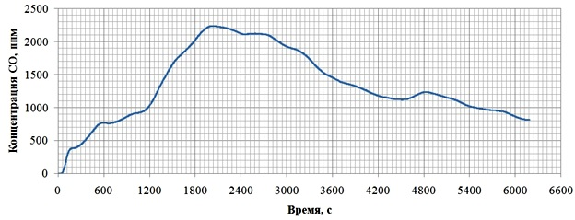 This can be also proved by the stove test on 13.12.15 in Murzinka. Concentration of СО is minimal, both at the beginning and at the end of firing. No increase of concentration was observed.
About the tests of stoves of free gas movement system
The research of flue gases with the help of gas analyzers Testo at damper in the system of free gas movement unlike the system of forced gas movement does not provide the correct result. Measurements of (СО), (СО₂), and oxygen (О₂), draft and flue gases temperature were taken. In accordance with them the coefficient of air surplus was calculated and also efficiency factor as per the method programmed by the manufacturer.
The systems of free gas movement and forced gas movement are principally different. The difference of free gas movement system from the forced gas movement system lies in the fact that hot СО₂ and Н₂О cannot be extracted from the bell (when blast and draft are equal) until they cool down. Ballast gases are not present in combustion zone and in the zone where the extracted heat is used. But they are present at the exit of the chimney. In other words, the use of the extracted energy in the system of free gas movement is better. The tests of stove of free gas movement should be carried out in hot air-heating chamber, or as per direct balance with measurement of heat given up by the stove from the stove surface. It is necessary to divide the stove surfaces into squares and measure temperature in each square. The time of experiment shall be taken as a «period of time passed from the initial average temperature value of stove brickwork until the final average temperature equal to the initial one». In this case we can compare the calorific value of the burnt fuel and heat given up by the stove as well as time of stove heat emission.
The application of free gas movement system in household stoves and boilers that showed good results in practice is only the top part of iceberg. For example, Content and results of workshop in Italy, http://kuznetsovstove.com/ru/94-soderzhanie-i-rezultaty-seminara-v-italii
Gasification of fuel in free gas movement system is the bottom part of iceberg that requires study. The results will be splendid.
The product of combustion of wood, carbon dioxide (СО₂) and water (Н₂О) are balanced in nature. They are needed for growth of new trees, which saturate the atmosphere with oxygen. Carbon dioxide from the irretrievable energy sources is not balanced in nature and creates greenhouse effect, harmful for the Earth atmosphere.
A significant difference of energy-saving of individual houses in Russia is tremendous use of local fuel, sometimes of low-quality but relatively inexpensive. The majority of the population living in individual houses use wood and coal as fuel. It shall also be noted that a great number of houses in the countryside in Russia are not provided with gas and another energy supply as a bypass variant. The energy supply lines are not reliable, often overloaded and do not meet energy supply parameters. The majority of the houses are being heated by stoves of old design with low efficiency factor and unclear combustion. This issue can be solved without very large investments, just by teaching the people the profession of stove-builder of new free gas movement system in technical colleges, as it was at the time of the USSR in accordance with request of employment exchange. This activity shall be organized and carried out by Energy center. The center shall carry out scientific research and preparation of teachers. It shall be provided with technical literature, and it shall elaborate special regulations and norms. Also experimental work shall be carried out, including work on fuel gasification.
At present fuel oil, gas and electricity are types of fuel that are quite expensive. Under such conditions ENERGY-INDEPENDENT heating and hot water supply of any type of houses and their purpose can easily be done with wood stoves of various functional purposes. The enterprises shall be provided with efficient and ecologically-friendly settlement boiler houses. The demand has grown up. Many people want to live out of town, in settlements where there are no centralized energy sources, with all modern conveniences. The system of free gas movement in accordance with the patent of the Russian Federation for invention No. 2553748 dt 22.05.2015, METHOD OF FUEL COMBUSTION allows to do that. In this case there is a possibility of getting many additional useful functions in the stove that cannot be provided by stoves of forced gas movement system.
Construction of energy-independent VEGETARIUM (all-weather winter green house) for private use and industry is also possible with the use of stove of our system.
Recultivation of wood can easily be done by planting deciduous trees that grow quick enough, such as: birch, poplar, aspen, willow, acacia, maple, etc. In a number of countries creation of special plantations of poplar and willow, quick-growing trees find a wide practical application. Sale of dry wood in Russia can be entrusted to «Gortop, Seltop», as it was done in the USSR.
IT SHALL BE POINTED OUT THAT IN FIREBOXES OF OUR STOVES CLEAR COMBUSTION OF COAL WITH A LARGE CONTENT OF VOLATILE GASES.

Литература:
1. Кнорре Г . Ф ., Арефьев К. М., Блох А. Г ., Нахапетян Е. А., Палеев И. И., Штейнберг В. Б. Теория топочных процессов . Под ред. Г . Ф . Кнорре и И.И. Палеева. М.-Л., 1966.
2. И.И. Грингауз «Паровые котлы», НКЭП СССР, Москва 1940 Ленинград;
3. Д.Б. Гинзбург (д.т.н.) «Газификация твердого топлива». Госстройиздат, 1958 г;
4. Элементарный учебник физики. Том I, Под редакцией академика Г.С.Ландсберга. Наука, Москва, 1972 г.

Notes:
* The complexity lies in the fact that two working substances, i.e. fuel and oxidant being in a relatively stable molecular state before being associated in new, more stable molecules of combustion products pass through the complex chains of destruction and recombination processes being in this intermediate period in unstable condition in the forms of atoms, radicals, oxides and peroxides with a relatively large ionization degree. These intermediate substances during a short period of there existence react with each other and also with primary molecules of fuel and oxidant coming into their zone thus creating sequential and parallel ramified chains of intermediate, the so-called ”elementary” reactions. Physical phenomena that prepare and accompany the ignition and combustion processes are also complex. In the majority of cases the amount of oxidant and correspondingly the combustion products is significantly exceeds the amount of fuel. Gas-air flow passing through these devices follows the laws of aerodynamics. Because of the non-homogeneous temperature field the aerodynamic phenomena are getting complicated with heat-exchange phenomena, and due to existence of gas-forming and heat extraction sources in this field – also with corresponding physical and chemical phenomena. Thus in the firebox one has to deal with complicated fields of velocity, concentration and temperature, with sources and exits which is very difficult for precise mathematic description. All the above mention process sides are interrelated and exert influence on one another (1).

I.V.Kuznetsov 06.10.17
620143 Ekaterinburg
Pobedy St. 51 - 87
Tel. (343) 3077303;
8 (912) 2880065 МТС
9 (912) 6816381 МТС
e-mail: igor@stove.ru
http://stove.ru
http://kuznetsovstove.com
http://stovekiv.com

I’m sending a complete variant of the article.

