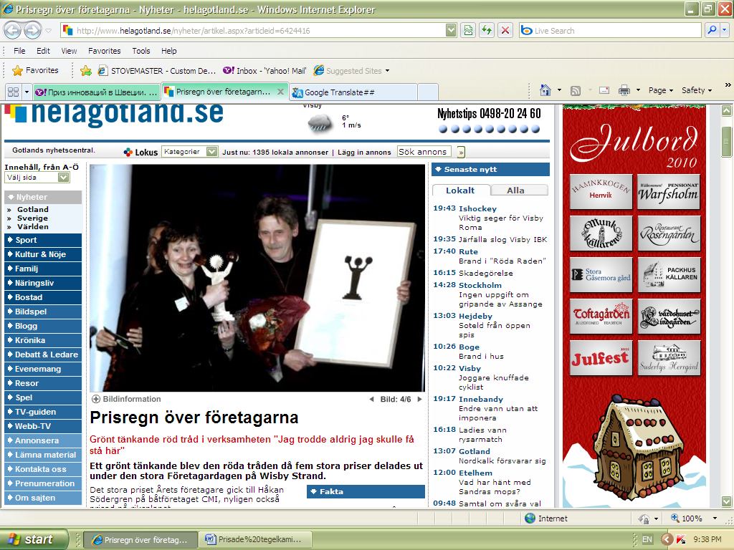
Praised brick stoves
Ecology and environmental friendliness pervades even the duo that won the innovation prize of Gotland. Husband and wife team Peter Ostberg and Tatyana Pavlova won the award for their brick stoves.
- We hope to start a vocational training for masons on Gotland, reveals Tatyana Pavlova Ostberg, who brought with her the idea behind the large, efficient stoves from his native Russia.

