Table of contents

1 introduction 2
2 suburb measurement 1991 3
3 suburb measurement 1994/95 4
4 suburb measurement 2000 5
4,1 starting situation 5
4,2 objective 5
4,3 items under test and documents 5
4,4 description of the products (items under test) 6
4,5 execution of the measurement 6
4,6 measuring instruments and measuring procedures 7
4,7 9
4,8 results of measurement 11
4.9 new realizations 15
5 summary 17
6 listings 18
6,1 illustrations 18
6,2 tables 18
7 appendix 19
7,1 detail results 19
7.2 supporting enterprises 19
7.3 exemplary photo documentation 20

introduction
Since beginning of the nineties-years at tiled stoves and also against all other heating systems strengthened very strict demands are made against the burn quality. While in earlier times the perfect function of the tiled stove was described by the fact that as good a utilization of energy as possible are made and the incineration gases completely by the chimney are exhausted, was added now the requirement after as complete a burn as possible.
The carbon dioxide developing during the wood burn in the tiled stove, the likewise developing water and also the nitrogen oxides represent products of a complete burn. While this admits with the two first mentioned components for a long time is, this fact is with the nitrogen oxides a relatively recent realization.
With each burn however also product of an incomplete burn develops. The probably most well-known example of it is Carbon monoxide (CO). The desire for a large avoidance of CO emissions has several causes. On the one hand during a transformation of carbon in the fuel in Carbon monoxide only one part of the energy is set free, for which during a complete transformation by carbon in carbon dioxide one produces. On the other hand Carbon monoxide represents also a very poisonous substance. Carbon monoxide works as blood poison, i.e. that CO in air can lead a connection of the oxygen to hemoglobin in the blood prevented and thus to an oxygen under supply. Beside Carbon monoxide also hydrocarbons are products of an incomplete burn.
These redefined requirements of the burn quality of heating systems were embodied in ever more laws. Thus came into force already at the beginning of the nineties-years into the Steiermark the firing plant permission regulation, which demanded very strict emission limit values for the new start-up of small firing plants. Soon thereafter the other Lands of the Federal Republic seized the resolution to issue Austria far uniform regulations for small firing plants. They agreed thereupon on the agreements in accordance with article 15a Federal Constitution law (Federal Constitutional Court) over „concerning preventive measures small firings “and over „the saving of energy “.
The situation described before led to the fact that in the last years intensive efforts of the tiled stove industry were accomplished for the burn improvement of the plants. Apart from the development and test activity on test stands, with which well reproducible results can be obtained, the measurement of tiled stoves suburb represents a very important instrument, in order to be able to determine the effects of the developments in practice. In the following the results represented at different times of the accomplished suburb measuring series are.

suburb measurement 1991
In the period of October until December 1991 by the delegated ones of the technical committee in the Austrian tiled stove federation together with the attempt and research institute of the Hafner Austria under the direction of Dr. Hermann yard farmer a first suburb measuring series at existing tiled stoves was accomplished. A goal of these measurements was an inventory collection of the tiled stoves in Austria. 31 tiled stoves were examined, which were distributed over the whole federal territory. As criteria for the measurements suburb the regulation that Carbon monoxide (CO) - emissions and the firing-technical efficiency (η) were consulted. The average value of the CO emissions amounted to 2,850 mg/MJ (without outliers 2,130 mg/MJ), the average value for the efficiency 83%. The allocation of the results in emission classes shows the following picture (illustration 1).
Illustration 1: Suburb measurement 1991 – CO emission classes
The data, like for example fuel conversion and excess air, taken up during this suburb measurement, formed the basis for the development of the computation method for the calculation of tiled stoves, which appeared as No. 1 of the series of publications of the Austrian tiled stove federation.

suburb measurement 1994/95
In the heating season 1994/95 a further examination of tiled stoves suburb took place, whereby only tiled stoves, which had been built after the again developed tiled stove computation program, were measured. This series of measurements took place again in co-operation of the attempt and research institute of the Hafner with the technical committee in the Austrian tiled stove federation. This time 20 tiled stoves, likewise distributed over completely Austria, were examined. As criteria for the burn quality and the energy efficiency of the tiled stoves again Carbon monoxide and the firing-technical efficiency were consulted. The average value of the computed furnaces amounted to for Carbon monoxide 1,400 mg/MJ, for the efficiency approximately 80%. The illustration 2 shows the organization of the carbon monoxide emissions of the measured furnaces into emission classes.
Illustration 2: Suburb measurement 1994/95 – CO emission classes
During the view that on the one hand the average value for the CO emissions could be lowered on approximately half of the emissions of the first suburb measuring series, on the other hand also no more tiled stoves arose, the suburb in an emission class over 3000 mg/MJ is noticeable to the illustration 2 lay.

suburb measurement 2000

starting situation
In the heating season 1998/99 under the leadership of the Federal Ministry for environment, youth and family the development of a study in order was given, which had the goal to compile the emission factors for heating systems with solid fuels. The order for the production of the study was issued to the Joanneum Research in Graz.
The measured heating systems were divided into 4 groups after the criteria Einzelofen/central heating and/or wood/coal. This had the consequence that the tiled stove was separately led and added to the group single furnace wood. For this category single furnace wood 29 objects were measured, under those only (!) Tiled stove was present. The average CO emission factor for the category single furnace wood was determined with 4.463 mg/MJ. This value lies however importantly over the emission factors of tiled stoves, which could already obtain substantially better values at earlier times.

objective
Since the study mentioned before was initiated by public side, one can assume the obtained results admission will find into various publications of national places. The Austrian tiled stove federation decided therefore, a study with same setting of tasks assigned to a neutral place to, which should accomplish this Messprozedere for tiled stoves.
A goal of the project was the determination of the average emission factors for the pollutants CO, NOx, OGC and dust of existing tiled stoves in Austria. 17 plants for the field survey were selected. The measurements were accomplished in the heating season 1999/2000. The tiled stoves were operated by the user according to its habits.

items under test and documents
The distribution of the items under test over the federal territory was specified as follows:
Castle country 2
Kärnten 2
Lower Austria 2
Upper Austria 3
Salzburg 2
Steiermark 2
Tirol 1
Vorarlberg 2
Vienna 1
If technical designs and/or computation documents of the tiled stoves were present, these were included into the documentation. In different collection sheets the following data were held:
- Measuring personnel
- Operator data
- Weather conditions
- Average yearly fuel consumption
- Maintenance, servicing and condition of the plant
- Building data
- Technical data of the tiled stove
- Description of the catch and the measuring and/or CO2-Eindüsungsstelle
- Assigned measuring instruments and calibration data
- Data for dust measurement
For the determination of the fuel dampness a fuel sample was locally pulled in each case.

description of the products (items under test)
The items under test were throughout in good technical condition. The Feuerungsanlagen became at least 12 hours before beginning of the measurement pre-heatedly, in order to ensure a stationary condition of the plants.
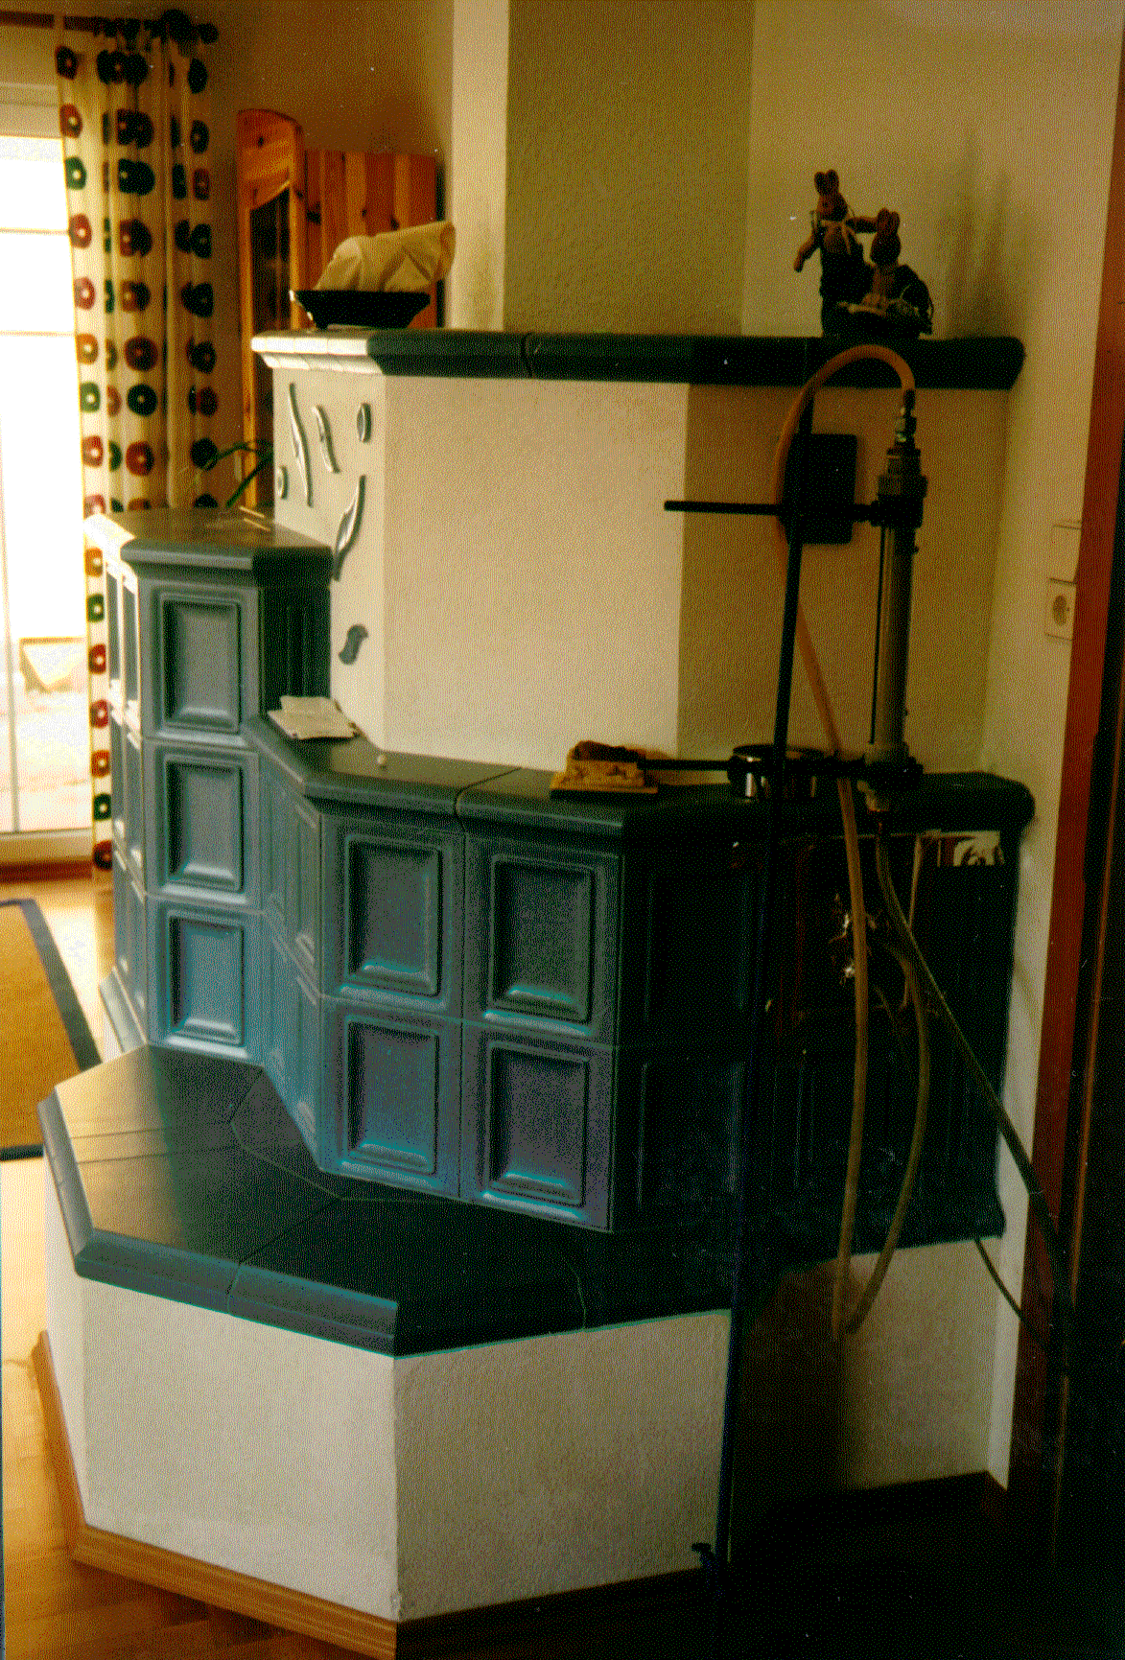
Illustration 3: Photo item under test

execution of the measurement
The measurement took place after possibility approximately with maximum load (full load enterprise). At increased outside temperatures the amount of fuel was reduced accordingly.
In distances of 3 seconds the concentrations CO2, CO2, CO, NOx, and OGC in the incineration gas as well as the incineration gas temperature were noted. The measuring period extended from igniting the fuel up to closing the Ofentür. The dust measurements were through accomplished in half hour intervals over the entire measuring period. The determination of the speed was made by the measurement of the CO2-Erhöhung in the incineration gas via the impulsweise Eindüsung of a defined quantity of CO2 into the Heizzug.

measuring instruments and measuring procedures
In the following the assigned measuring instruments and measuring procedures are stated.
Oxygen
Measurement principle | The principle for the measurement of the Sauerstoffkonzentration is based on its paramagnetic characteristics.
Carbon dioxide/Carbon monoxide
Measurement principle: | NDIR measuring procedures are based on the fact that some gases (e.g. CO, CO2) absorb light of defined frequency in the IR range. The absorption of IR radiation is directly proportional the gas concentration and can be consulted therefore for the quantitative regulation.
Nitrogen oxides
Measurement principle: | From addition from ozone to the sample gas electronically lively NO2 results with presence of NO. This changes under emission from electromagnetic radiation (Chemiluminiszenzlicht) into the initial state. The intensity of the light is a direct measure for the NO concentration in the sample gas.
Organic, gaseous hydrocarbons
Measurement principle: | The flame ionization detector (FID) uses the ionization of organically bound carbon atoms in a hydrogen flame as measuring effect. The ion stream arising with it in a field is electrically strengthened and indicated.
Incineration gas flow rate
The determination of the volume stream took place via task of a defined quantity (approx. 2.5 Nm3/h) tracer gas for the incineration gas and the measurement of the concentration of the tracer. By the measured concentration over the tracer gas dilution the flow rate and/or the incineration gas speed is calculated.
The dosage of the CO2-Tracergases took place usually during a defined finery opening of the tiled stove with a minimum distance to the measuring point of 3.5 meters around the mixing of the tracer gas with the flue gas to guarantee.
The dosing time of the tracer gas amounted to 1 minute, the break time amounted to 3 minutes.
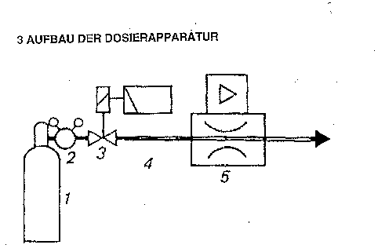
Illustration 4: Carbon dioxide (CO2) - Eindüsung
- CO2-Druckgasfla without tubing
- heated pressure-reducing valve
- magnet stop valve
- digital time delay relay
- mass flow automatic controllers (MFC)
Gas temperature
The measurement of the gas temperature takes place with a NiCr never coat thermocouple - type K.
Pressure measurement
The pressure measurement takes place with a gauge of the company Klimatherm type KDM3 with a measuring range from 0 to 1.999 mbar.
Recorder
The by EDP collection of the measuring data with PC (Pentium 133 MHz) took place by means of Datenlogger dolphin ADG.
Dust
Measurement principle
There one for the statement of the dust content a gas flow (main stream) because of the usually large quantities generally not in its whole to suck off can, a low gas stream is sucked off. From this the powdery materials contained in it become filtered. That dust content is the separated dust mass, related to the volume of the component current. One receives a representative dust sample if the low gas stream with the same speed, which the main gas flow has, is sucked off. The withdrawal of the low gas stream from the main gas flow, as well as the separation of the dust contained in the low gas stream take place with a plant, consisting of:
Withdrawal probe | : | Single probe after VDI 2066 (from steel corrosion resistant with smooth inner walls)
Dust collection | : | In the probe sitting high-grade steel cases with quartz wool
Mass of gas measurement | : | Gasuhr (bellow gas meter)
Sucking off equipment | : | Vaccum pump, which sucked off low gas flow rate can by a bypass active putting is in-adjusted
Filter conditioning | : | Drying furnace (105 °C, approx. 4 hr.), Exsikkator (approx. 1 hr.)
Accuracy of the measurement | : | +/- 1 mg/Nm3
Lower detection limit | : | 1 mg/Nm3
The measurement setup for the suburb measurements can be taken from the following principle sketch as well as the photo.
Illustration 5: Measurement setup – principle sketch
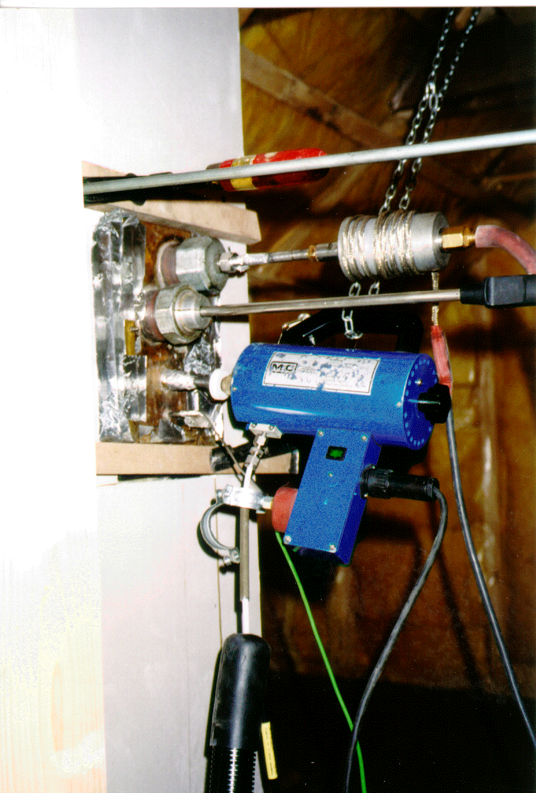
Illustration 6: Photo sampling
The sample gas was taken out of the Heizzug over a probe. First the gas was released by a heated filter from quartz wool from dust. Over one on approx. 160 ºC heated line arrived the sample gas at the further gas preparation. The flue gas was released by cooling on approximately 5 ºC from the largest part of the water. By means of a pump the in such a way prepared gas was supplied to the individual analyzers (CO2, CO2, CO and NO).
The FID was fed by a separate heated line (160 °C) with filter.
The measuring point for the dust withdrawal was in senkrechten a part of the incineration gas guidance. An in as well as discharge distance were present, so that the measuring point corresponds to the guidelines of the ÖNORM M 5861.

results of measurement
A compilation of selected average values of all measurements supplies the following table:
Achievement (KW) | Amount of fuel (kg) | Conversion (kg/h) | Water content (%) | Excess air (-) | Time (min)
4,7 | 13,8 | 11,4 | 7,6 | 4,3 | 75
CO (mg/MJ) | NOx (mg/MJ) | OGC (mg/MJ) | Dust (mg/MJ) | Efficiency (%) | Exhaust gas temperature (°C)
820 | 81 | 53 | 58 | 81,2 | 143
Table 1: Characteristic values of the field survey 1999/2000
In the following the obtained emission results as well as the firing-technical efficiencies of the individual tiled stoves are aforementioned. To the comparison the average value and in the agreement in accordance with article 15a the Federal Constitution laws over „concerning preventive measures small firings “demanded limit value were stated. To note it is with the fact particularly that the 15a limit value is to be proven suburb only on the test stand, not however.
Illustration 7: Carbon monoxide (CO) - emissions
Illustration 8: Nitrogen oxide (NOx) - emissions
Illustration 9: Hydrocarbon (OGC) - emissions
Illustration 10: Dust missions
Illustration 11: Firing-technical efficiency (η)
During the view of the emission values of CO, NOx, OGC and dust it is noticeable that the obtained emission factors (d.s. average values of typical results of measurement suburb) are to small firings under the limit values of the agreement in accordance with article 15a Federal Constitutional Court over „concerning preventive measures “. It is again pointed out that these values at the test stand are to be kept, not however suburb.
The firing-technical efficiency η, which was determined during the suburb measurement, lies over the minimum value of 78%, as it is required in the agreement in accordance with article 15a Federal Constitutional Court over „the saving of energy “again for the test stand.
In the illustration 12 the values of the investigation of the Joanneum Research are aforementioned on behalf the federation for the determination of the emission factors for firm of fuels to the comparison. With respect to this investigation between the fuels wood and coal were only differentiated and between Einzelofen and central heating. Its own group for tiled stoves did not give it.
Illustration 12: Emission factors of combustions of wood in the comparison
It shows up in this illustration clearly that the tiled stove under the combustions of wood exhibits the best results at all emission values.

new realizations

dust missions
A substantial new realization concerns the dust missions. So relatively large fluctuations of the dust values could be observed with the measurements. With exact analysis it was stated that the dust values of 2 factors are considerably affected. These factors are the incineration gas speed in the Heizzug and the number of detours per course length. It shows itself that the dust values are the lower, the are more highly the speed (illustration 13) and the smaller the number of detours per course length (illustration 14).
Illustration 13: Dependence of the dust missions on the speed
Illustration 14: Dependence of the dust missions on the detours per course length

tightness
Further it could be stated that the tightness of the examined plants was quite different. This showed up on the basis the measurement of the exhaust speed before and after the Zusperren. The closer plants had both with the emissions arising after locking off and with the losses of energy developing in this phase clear advantages. Thus it shows up that a careful expert execution possesses a relevant portion of the quality of the tiled stove with the building of furnaces.

further procedure way
The realizations concerning the dependence of the dust missions and concerning the tightness represent important beginnings for a further possible optimization of the burn quality with the tiled stove.

summary
The attempt and research institute of the Hafner work constantly to hold the products set by the Hafner on the newest state of the art. Thus for ways was looked for intensively, in order to keep upright the individual building method extremely estimated with the tiled stove and keep nevertheless the emission regulations. A piercing success could be obtained with the introduction of the EDP-supported computation program. It was not only reached that work is saved to the Hafner and supplied with to the customer professionally more planned and optimally a furnace adapted to the fire-place, but also a clear reduction of the emissions (illustration 15) and an increase of the efficiency could be achieved.
Illustration 15: Development of the CO emission factors by technical advancement
The same procedure way, suburb measurement, development of a computation guideline, examination of the guideline, was accomplished also for the Kachelherd. Individual measurings with again set Kachelherden, already accomplished, show same success also with this Hafnersystem.

listings

illustrations
Illustration 1: Suburb measurement 1991 – CO emission classes 3
Illustration 2: Suburb measurement 1994/95 – CO emission classes 4
Illustration 3: Photo item under test 6
Illustration 4: Carbon dioxide (CO2) - Eindüsung 8
Illustration 5: Measurement setup – principle sketch 9
Illustration 6: Photo sampling 10
Illustration 7: Carbon monoxide (CO) - emissions 11
Illustration 8: Nitrogen oxide (NOx) - emissions 12
Illustration 9: Hydrocarbon (OGC) - emissions 12
Illustration 10: Dust missions 13
Illustration 11: Firing-technical efficiency (η) 13
Illustration 12: Emission factors of combustions of wood in the comparison 14
Illustration 13: Dependence of the dust missions on the speed 15
Illustration 14: Dependence of the dust missions on the detours per course length16
Illustration 15: Development of the CO emission factors by technical advancement17

tables
Table 1: Characteristic values of the field survey 1999/2000 11

appendix

detail results
Ber.- No. | Fig. time | CO2 | CO2 | Lambda | Wirkgr. | CO | NOx | OGC | Dust
- | (min) | (Volume of %) | (Volume of %) | (-) | (%) | (mg/MJ) | (mg/MJ) | (mg/MJ) | (mg/MJ)
1 | 72 | 14,9 | 5,9 | 3,6 | 80,5 | 535 | 47 | 31 | 82
2 | 90 | 16,8 | 4,0 | 5,2 | 73,6 | 583 | 51 | 66 | 62
3 | 85 | 16,7 | 5,0 | 4,2 | 87,1 | 972 | 48 | 91 | 69
4 | 110 | 16,0 | 5,2 | 4,0 | 74,6 | 1467 | 72 | 122 | 45
5 | 100 | 17,8 | 3,0 | 7,0 | 82,4 | 438 | n, g, | 16 | 31
6 | 65 | 14,7 | 6,8 | 3,0 | 78,7 | 1000 | 112 | 66 | 8
7 | 55 | 15,5 | 5,6 | 3,7 | 82,3 | 791 | 109 | 55 | 9
8 | 65 | 16,6 | 4,3 | 4,8 | 84,9 | 655 | 118 | 33 | 43
9 | 75 | 13,7 | 7,1 | 2,9 | 87,1 | 1331 | 76 | 83 | 102
10 | 55 | 14,8 | 5,9 | 3,5 | 91,5 | 1110 | 122 | 67 | 30
11 | 65 | 12,4 | 8,3 | 2,5 | 80,7 | 1158 | 86 | 16 | 51
12 | 105 | 16,1 | 4,4 | 4,7 | 75,8 | 336 | 17 | 17 | 57
13 | 55 | 16,3 | 4,3 | 4,8 | 79 | 942 | 72 | 43 | 96
14 | 45 | 14,0 | 6,7 | 3,1 | 82,3 | 1032 | 80 | 84 | 44
15 | 60 | 15,6 | 4,9 | 4,2 | 83,4 | 505 | 94 | 34 | 68
16 | 60 | 14,8 | 5,6 | 3,7 | 80,0 | 647 | 104 | 52 | 103
17 | 120 | 17,8 | 2,7 | 7,6 | 75,8 | 441 | 95 | 29 | 88

supporting enterprises
Owing to is entitled to the supporting enterprises, which often did not have it easily to motivate the operators of the plants for this project.
Buxbaum (C), Freinberger (OÖ), resound oh (NO), Huber (s), Lehner (B), Moser Larcher (T), Panek (W), Ratz (V), Thurner (T), rubble (OÖ), Ullrich (NO), Wallner (sp), Wittek (NO)

exemplary photo documentation
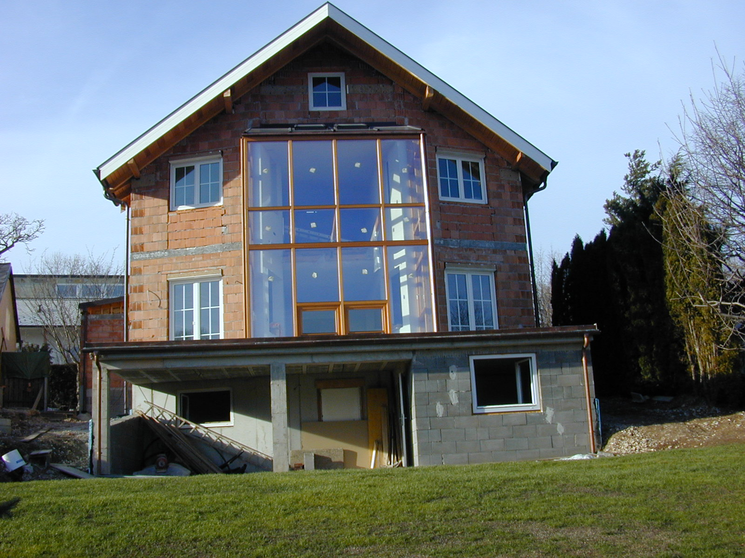
House
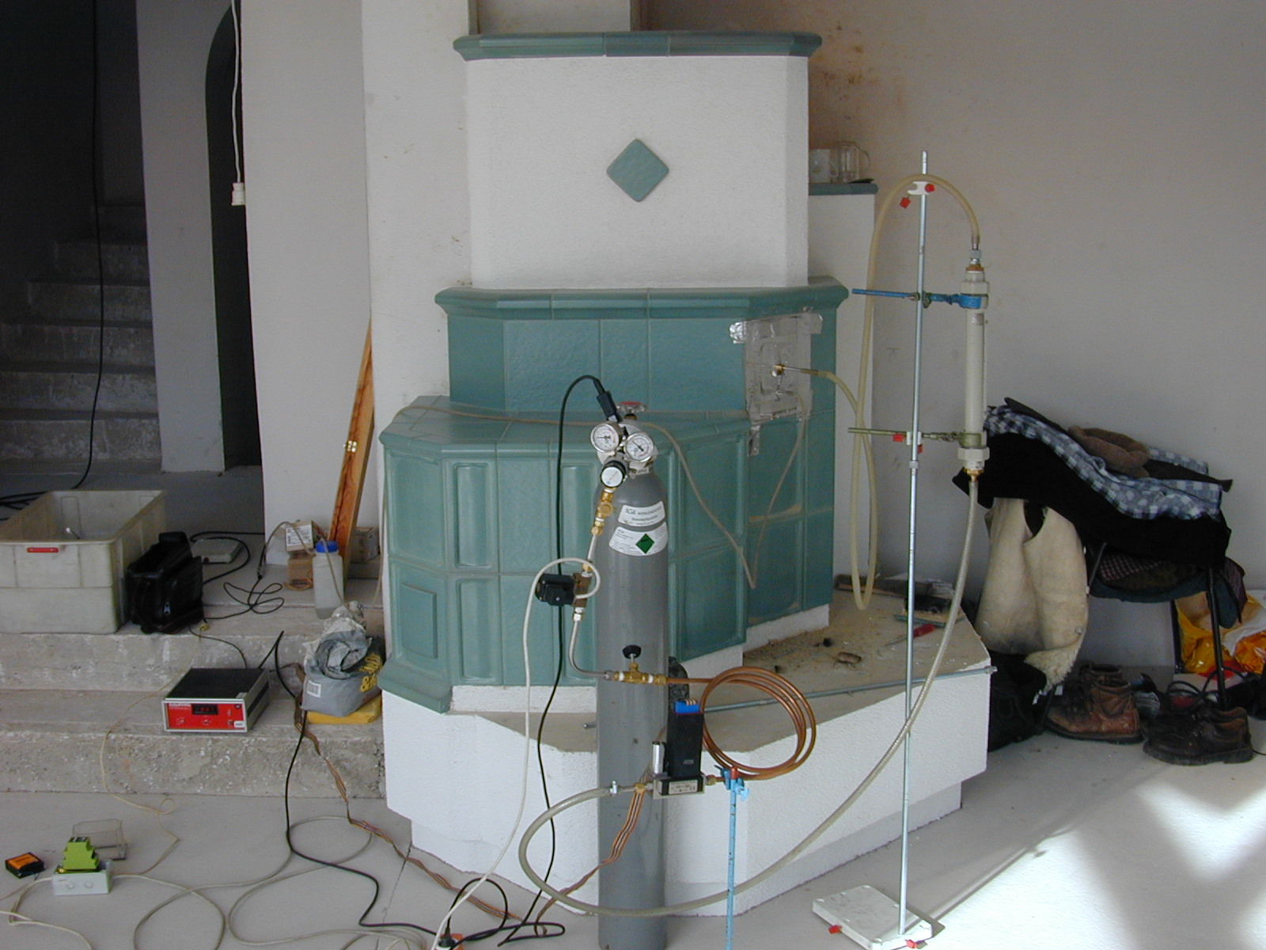
Tiled stove
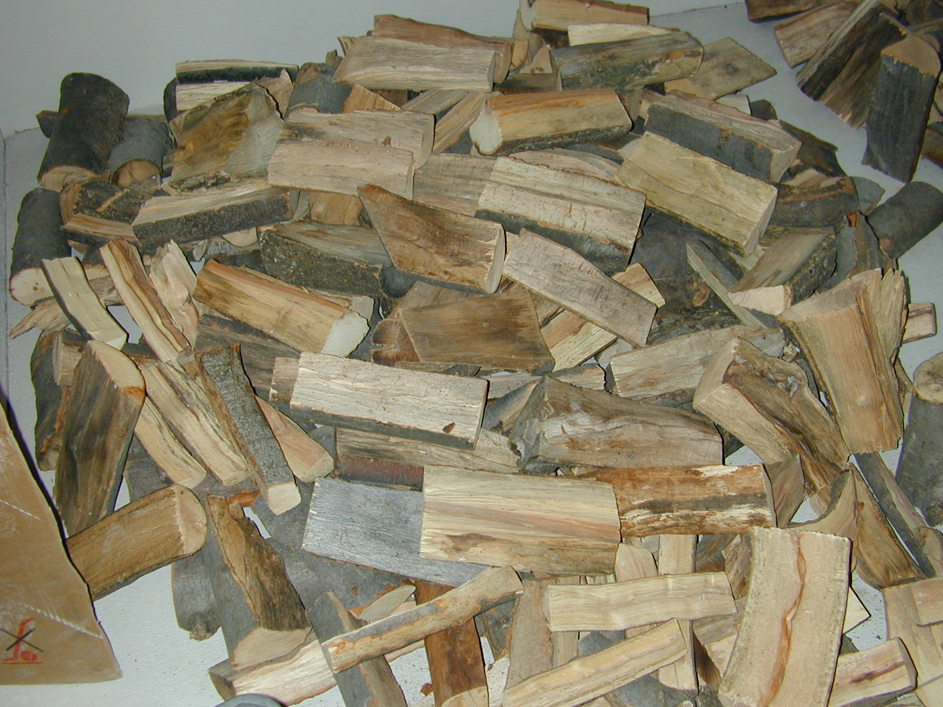
Fuel
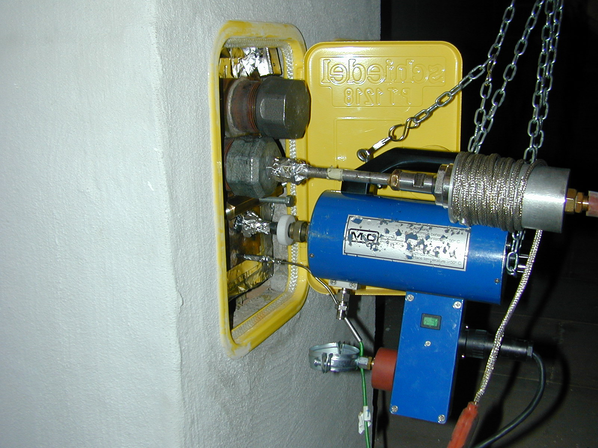
Measuring point

