Comparison of furnaces of different convective systems
Combustion is a chemical reaction during which from two simple matters, carbon (С) and hydrogen (Н₂), in combination with oxygen (О₂), other matters are formed with heat release. When we heat fuel it is divided into volatile part consisting of carbon and hydrogen and solid residue, carbon. The volatile part is called hydrocarbon.
Combustion processes can be expressed with the help of chemical equations showing in what proportions and how simple matters react.
С+О₂=СО₂+7940 kcal/kg С, - formula 1,
Н₂+1/2О₂=Н₂О+2579 Kcal/Nm³ Н₂ , - formula 2,
СО+1/2О₂=СО2+3018 Kcal/ Nm³СО, formula 3.
If air is used as oxidant, during efficient combustion, the output is carbonic acid (СО₂) from carbon, water vapours (Н₂О) from hydrogen. These are heat sources formed in the result of chemical reaction of combustion. Besides there is nitrogen as a component of the air used for combustion which represents 4/5 of the output volume. Actually, due to the unequal mixing of the carbohydrate with air, air has to be supplied at a rate of 1.6 to 2.4 times the theoretical amount required. Therefore, there is always a surplus of air in the firebox that did not really take part in the combustion process plus the water vapours from water normally present in fuel. All these gases are called ballast gases, that is, they do not take part in combustion but only get heated from the combustion of carbon and hydrogen. In other words, they reduce the useful heat. The molecules of the above-mentioned gases are totally independent, that is, they are not coupled with each other.
The stove consists of the firebox, convective system and chimney. Convective system is a tool for using the extracted heat energy that could be used for heating boiler, heater and heat-accumulating massive, etc.
At present all stoves being built can have the following convective systems:

Fig.45 Convective systems of stoves:
- serial; b) parallel; c) channelless (bell-type); d) combined; e) with air chamber
1- monoreversible, 2- double-reversible, 3-multireversible, 4- air chamber

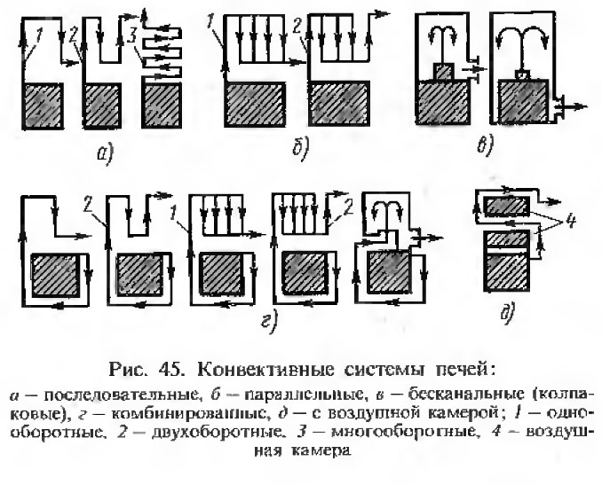
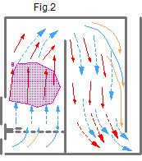
All these stoves have one feature in common. In the combustion chamber combined with convective system movement of gas flow formed during fuel combustion is made due to chimney draft. The products of combustion reaction are mixed to form a single flow. All these stoves are based on forced gas movement.
The products of combustion reaction consist of a mixture of gases not connected with each other. Part of these gases is heat sources, another part - heat consumers. They get mixed in the flow. Fig.2. The conditions of fuel combustion as well as preservation of heat extracted from the fuel get worse.
A goal is to improve the conditions of fuel combustion by separating the gas flow. The gases that are the heat sources shall be used efficiently. Ballast gases that are heat consumers shall be taken away from the stove, cooling the stove little. The amount of water vapor coming out from chimney shall be reduced as they take away the heat used for heating them. This shall be done using the laws of nature. Gases can be separated only at the stage of their formation.
The new system stoves (Free gas movement system) are built in accordance with my RF patents for inventions No. 2055272 dt. 27.02.1996 and No. 2553748 dt. 22.05.2015 METHOD OF FUEL COMBUSTION. In the combustion chamber combined with convective system movement of gas flow formed during fuel combustion is made due to heat exchange process
The first step to create the Free Gas Movement system.
The stoves in which”the lower level and the firebox are combined to form a single space creating a lower bell” are made in accordance with RF patent No. 2055272. This type of stove is characterized by unusual flexibility.
The firebox and the bell are combined by means of a vertical crevice of 2-3 cm (hereinafter called “dry joint”). Such design makes it possible to create both in the bell and in the firebox the conditions in which movement of gases is in accordance with their natural strive: the hot gases tend to flow upward and streams of cooled gases tend to go down only due to the heat exchange processes (when blast and draft are equal). Intensive heat exchange from the firebox to the bell will take place through the “dry joint” due to convection and diffusion without chimney draft. The lower bell will have no vertical vector of chimney draft. Natural gas movement will take place in the firebox. The “dry joint” principle can be seen from the following example. If during winter the door or window is open for 2-3 cm, an intensive heat exchange will take place. The more is the temperature difference inside and outside, the more is the heat exchange.
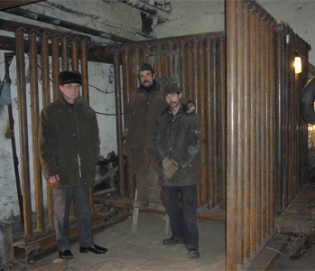
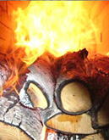
This made it possible to create thousands of new designs of high-efficiency stoves and boilers of different functional purpose. There is a possibility of creation of unlimited number of heat generators with different power rate and purpose, with new functional requirements, including industrial-type generators.
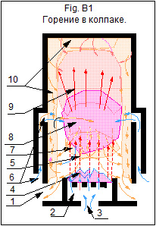
An example of free gas movement system flexibility is shown in the picture of boiler heat exchanger which is inserted in the bell. Not the heat exchanger is inserted in the firebox but the firebox with “dry joint” is inserted into the heat exchanger. Combustion in the boiler firebox is shown in the picture.
The second step to improve the “Free Gas Movement” system.
RF patent for invention No. 2553748 dt. 22.05.2015 METHOD OF FUEL COMBUSTION.
Lets look at the process of fuel combustion in the bell shown in Fig. B1
Bell is a vessel turned upside down. 1- exit for gases from the bell (no draft); 2- breeze; 3- primary air; 4- fuel; 5- hydrocarbon; 6- secondary air; 7- harmful ballast gases; 8- combustion reaction zone; 9- useful products,- СО₂ and Н₂О; 10- heat exchange zone;
If we burn wood at the bottom of the bell (Fig. B1), volatile inflammable gases will arise. They consist of a mixture of carbon-С and hydrogen-Н₂. If air is supplied into the middle part of the firebox, a combustion reaction will take place that can be expressed with the help of chemical equations
С+О₂=СО₂+7940 kcal/kg С, - formula 1,
Н₂+1/2О₂=Н₂О+2579 kcal/Nm³ Н₂ , - formula 2
The proportion of substances that will react during chemical reaction is met as well as their content. That is carbon- С, will react with hydrogen- Н₂, and with oxygen - О₂, in quantity determined by the chemical equation. Other substances cannot take part in chemical reaction. In this case one can speak about fuel heat content during its oxidation by pure oxygen, similar to acetylene combustion by pure oxygen from bottles. At present time the fuel heat content value is given for oxidation by oxygen present in the air that is with ballast gas nitrogen.
The combustion products are subdivided in accordance with heating degree. Hot particles, carbonic acid gas and water vapors flow upward. Ballast gases go down and flow out from the bell through the zones close to heat exchange surfaces. Gas flow movement takes place due to heat exchange processes without chimney draft. During fuel combustion in the bell hot gas energy is accumulated, concentrate and is used in the bell. From the lower part of the bell only cold gases can go out. The bell can have any form and volume.
Let’s look at the features and capabilities of stoves of different systems.
THE STOVES OF FORCED GAS MOMENT SYSTEM IS A PREVIOUS LEVEL OF TECHNIQUE.
During many years the design of power installations of forced gas movement system in relation to heat engineering has been made to maximum possible high level and practically they cannot be improved any more.
- The stoves of forced gas movement system cannot meet the requirements in multifunctional stoves and boilers of different power rate in many houses and satisfy customers’ needs.
- During chemical reaction of combustion heat carriers arise, carbonic acid (СО₂) from carbon and water vapors (Н₂О) from hydrogen as well as cold ballast gases. In firebox of forced gas movement system stoves they get mixed, the temperature of the gas flow decreases, the conditions of fuel combustion as well as usage the extracted heat worsen ;
- There is no place for placing the heat exchanger in the forced gas movement system stoves.
3.1 The heat exchanger placed inside the firebox decreases temperature in it, thus worsening the conditions of combustion.
3.2 In the upward-going channel of large section the gas flow is distributed nonuniformly. (In places where the temperature is higher in the section the chimney draft force is summed up with Archimedes aerodynamic lift).
3.3 In downward-going channel, for example, in stoves of counterflow, the gas flow is distributed uniformly along the section (should in some place the temperature be higher, here Archimedes force arise that brakes the chimney draft). The gas flow is distributed ever the section, its temperature decreases, and it’s in constant motion, the heat exchange worsens.
- The cooled flow is running with a large speed through the stove channels upward, down, left and right with high speed, thus reducing the contact time and worsening heat exchange of gases with heat exchange surface.
- Owing to above-mentioned reasons in the forced gas movement system it is not possible to create a great many multifunctional stoves of different power rate in accordance with ever growing demand. Due to the same reason it is also impossible to create a lot of ecologically friendly boilers of different power rate. Due to this, the construction of boilers using solid fuel is prohibited by law in North America.
- Heating of the first and last channel is nonuniform. There is a danger of crack formation on the stove.
- It is difficult to control the time of firing end of the firebox and closing the damper. If it is closed too early, one can get poisoned by carbon monoxide. If it is closed too late the stove cools down quickly. In other words, if the damper is not closed in proper time, big heat losses are inevitable.
- The combustion products are usually extracted at such high temperature that water normally present in such products is usually in the form of vapor. In this case water vapors do not transfer heat spent during combustion on water evaporation, and the heat is lost. At temperature below 100 ^{о}С, condensate is formed which leads to premature chimney destruction.
- At the final stage of combustion when charcoal is left in the firebox the concentration of СО increases. Due to lack of oxygen the combustion becomes incomplete. It can be explained by the fact that air in the forced gas movement system in the firebox flows straight up due to chimney draft and has a low impact on carbon (charcoal). Due to that reason during ecology test of stove this period is not taken into account.
Free Gas Movement system stoves, NEW LEVEL OF TECHNIQUE
Free Gas Movement system provides an opportunity of creating an unlimited number of heat generators of different power rate and purpose to meet new functional requirements, including industrial type heat generators.
Separation of gases takes place in the firebox. Combustion products are subdivided into components in accordance with their heat degree. Hot particles, carbon dioxide gas and water vapors rise upward where they are efficiently used. Ballast gases go down. Extraction of ballast gases from combustion zone increases efficiency of heat extraction from fuel.
The heat generators are provided with space for placing the heat exchanger. The heat exchanger is placed in the bell. The fuel is burn in the firebox efficiently and the heat emission is used in the bell.
During fuel combustion in the bell the energy of hot gases is accumulated and concentrated in the bell. Only cold gases can be extracted from the low part of the bell. The bell can be of any form and volume. The bell is heated uniformly in each section by height and has an increase crack resistance.
When damper is closed not in proper time the stoves cool down little. They are provided with “effect of automatic gas damper”. Cold air from ash box flows through the bottom part of bell, thus cooling down the stove very little.
Hot particles of water vapor provide the heat exchanger with heat and cold particles go down. In this case water vapors react with carbon (hot charcoal). In the result of chemical reactions water gas is formed which is burnt. The process of water gas burning can be described by two reactions:
С+Н₂О=СО+Н₂+2802 kcal/Nm³ heat.
С+2Н₂О=СО₂+2Н₂+1714 kcal/ Nm ³ heat
During the first reaction only inflammable gases are produced (50% СО and 50% Н₂). The calorific efficiency of mixture of these gases is 2802 kcal/Nm³. The first reaction requires an increased temperature.
During the second reaction partially inflammable and partially noninflammable gases are produced (33,3% СО₂ and 66,7% Н₂). The calorific efficiency of mixture of these gases is 1714 kcal/Nm³.
It shall be pointed out that in this case no heat is used for water vapors formation. Water vapors were formed as a result as product of hydrogen (Н₂) combustion.
Fuel water vapors being cold in the condition of bell cannot rise to the upper part of the bell; they pass over carbon and react with it. Also water gas is produced which is burnt. When the temperature of the exhaust gases in the chimney is below 100 ^{о} С, there is no condensate. This can be confirmed by the tests performed in Sweden at EKONOMKA MURSPISAR, http://www.ekonomka.se . There was no condensate in chimney although the temperature of the exhaust gases was below 100 ^{о}С.
At the final stage of combustion charcoal is present in the combustion chamber. If it is not oxidized by air, we will have incomplete combustion with extraction of carbon dioxide, which is the case in stoves with forced gas movement system. In free gas movement system air comes into the firebox through fire bar and openings for secondary air supply, and being cold, it lowers down into the lower zone where it reacts with carbon and burns it thus forming carbonic acid,
СО₂ and carbon monoxide- СО (inflammable gas), reactions: С+О₂=СО₂; 2С+О₂=2СО. In this case carbon monoxide is burnt with additional heat extraction, СО+1/2О₂=СО₂+3018 kcal/Nm³ СО, (formula 3). Complete combustion is ensured.

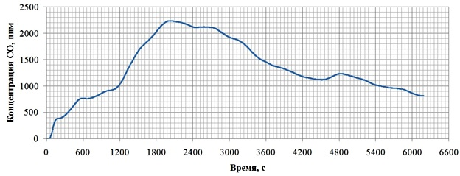 The tests of stove performed on 13.12.15 in Murzinka confirm this. Concentrations of СО are minimal at the beginning and at the end of firing. No concentration increase was observed.

I.V. Kuznetsov 05.07.16
620143 Ekaterinburg
ul. Pobedy 51, kv. 87
tel. (343) 3077303;
8 (912) 2880065 MTS
9 (912) 6816381 Megafon
e-mail: igor@stove.ru
http://stove.ru
http://kuznetsovstove.com
http://stovekiv.com

